AUTOMATIC IDENTIFICATION OF CLASS COHERENT AND HIGHRARACHIY TO IMPROVE MULTI-CLASS CLASSIFICATION PROBLEM.

Ranganadh Kodali
Student ID: 927723

Under the supervision of
Sanchit Aggarwal

A thesis submitted in fulfilment of the
requirements for the award of the degree of
MASTER OF SCIENCE IN MACHINE LEARNING AND ARTIFICIAL INTELLIGENCE

LIVERPOOL JOHN MOORES UNIVERSITY (LJMU)

Abstract

Document categorization is the oldest problem of information retrieval from text documents. Text documents usually contain a lot of detailed information and sometimes it may contain information related to multiple contexts. It is common practice for document management systems to associate a document with certain meta tags and enable end-users to easily locate necessary documents by a different set of classes. Especially in the case of news agencies / regulatory bodies, they need to label articles with multiple fine-grained information which will enable them to locate and search content easily. But keeping fine-grained features always a difficult task because sometimes, labels are transformed from one keyword to another or involve human bias of tagging documents with the unreasonable label.

Solving automatic document tagging through machine learning is a complex problem especially when the documents are labeled by different individuals and in a different period, context. In case if the model doesn't understand the relationship between labels, the classification algorithm may try to discriminate between both sets of documents even in reality these labels have some kind of parent-child relationship. This potential leads to higher misclassification in model predictions. And another common problem of applying classification for highly dense classes even business demands to summarise at the finest set of classes or vice-versa.

The purpose of this study is to develop an effective technique for constructing hierarchical label structure to facilitate the choice for researchers to implement news classification ranging from a finite set of classes to a dense set of classes. And improve the news classification without compromising much on the granularity of class labels.

Table of Contents

Abstract 2
CHAPTER 1 INTRODUCTION 8
1.1 Background of the Study 8
1.2 Problem Statement 10
1.3 Aim and Objectives 11
1.4 Research Questions 11
1.5 Scope of the study 12
1.6 Out of scope 12
1.7 Significance of the study 13
CHAPTER 2: LITERATURE REVIEW 14
2.1 Introduction 14
2.2 Text processing and feature extraction 14
2.2.1 Tokenization 15
2.2.2 Stop Words 15
2.2.3 Lemmatization and Stemming 15
2.2.4 Word Feature extraction 15
2.2.5 Document vectorization: 17
2.3 Multi-Label Learning (MLL) 19
2.3.1 Simple Problem transformation 19
2.3.2 Label powerset 20
2.3.3 Binary relevance (BR) 20
2.4 Hierarchical classification 21
2.4.1 Technique in solving Hierarchical classification 22
2.4.2 Local Classification per Node (LCN) 23
2.4.3 Local Classifier per Parent Node (LCPN) 23
2.4.4 Local Classification per Level (LCL) 24
2.4.5 Global classification 24
2.4.6 Constructing Hierarchical class 24
2.5 Neural network implementations 25
2.6 Domain-Specific 26
2.7 Summary 27
CHAPTER 3: METHODOLOGY 29
3.1 Introduction 29
3.1 Dataset description 30
3.1.1 Document Analysis ({X}-Labels): 31
3.1.2 Label analysis ({Y}-Labels): 34
3.2 Data pre-processing 35
3.3 Elimination of coherence labels. 36
3.3 Feature extraction. 37
3.4 Proposed Model: 38
3.5 Model evaluation 39
3.6. Expected Outcomes 40
3.7 Summary 40
CHAPTER 4: ANALYSIS & IMPLEMENTATION 42
4.1 Introduction 42
4.2 Pre-processing 43
4.2.1 Tokenization and Lexical treatment 43
4.2.2 Treatment for extreme documents 45
4.2.3 Label analysis 46
4.2.4 Splitting data to train and test 47
4.3 Feature Engineering 47
4.4 Label tuning 51
4.4.1 Constructing Document to Topic table 52
4.4.2 Document to Label table (D2L) 52
4.4.3 Label to Topic relation matrix (L2T) 52
4.4.4 Label to Label similarities (L2L) 53
4.4.5 Label replacement for recurrent labels 55
4.4.6 Construction of Label hierarchy 57
4.5 Model Development 59
4.5.1 Deep Neural network 60
4.5.2 LSTM recurrent neural network 62
4.6. Tools 65
4.6.1 Hardware requirements 65
4.6.2 Software Requirements 65
4.6. Summary 65
CHAPTER 5: RESULTS AND DISCUSSIONS 67
5.1. Introduction 67
5.2. Effectiveness of Label hierarchies 67
5.3. Results of DNN model 69
5.4. Results of LSTM model 70
5.5. Example Results 71
5.5. Model Compression 73
5.6. Answering research questions 74
5.7. Summary 75
CHAPTER 6: CONCLUSIONS AND RECOMMENDATIONS 76
6.1. Introduction 76
6.2. Discussion and conclusions 76
6.3. Contribution to the knowledge 78
6.4. Future Recommendations 78
REFERENCES 80
APPENDIX A: RESEARCH PLAN 84
APPENDIX B: RESEARCH PROPOSAL 85
APPENDIX C: ETHICS FORMS 86

LIST OF FIGURES
Figure-1 Example of tree structure hierarchy 22
Figure 2 Example of DAG structure hierarchy (Freitas, 2007) of one leaf node has two parents. 22
Figure 3 Problem solving process followed during research 30
Figure 4: Original Document length distribution 32
Figure 5 : After elimination of extreme documents 32
Figure 6: word cloud representation of the text documents shows most freqent words in the corpus 33
Figure 7: Number of labels distribution 34
Figure 8: Number observations per label 34
Figure 9: Benchmarking dataset accuracy over time 40
Figure 10: High-level implementation process 42
Figure 11: Number of words distribution after applying word treatment 45
Figure 12: Documents by Length 45
Figure 13: Number of Occurrences of words in Training Data set 47
Figure 14: Process of Label treatment 51
Figure 15 Example of Label to Topic matrix 53
Figure 16: Example of Label 2 Label similarities 54
Figure 17: Deep neural network low-level architecture 60
Figure 18: LSTM neural network low-level architecture 62
Figure 19: Model-1 DNN Level-1 (61 labels) precision @k =1 69
Figure 20: Model-1 DNN Level-1 (61 Labels) Categorical Accuracy 69
Figure 21: Project Plan 84

LIST OF TABLES
Table 1: Description of the database structure 31
Table 2 : Number of unique word and its number of times occurred in the data set 32
Table 3: Few examples of common label cooccurrence attached to the same new article. 35
Table 4: Number of experiments going to be conducted with this research 41
Table 5: Word cleaned through word segmentation 44
Table 6: Number of Observations for label 46
Table 7: Hyperparameters for TFIDF 48
Table 8: Topi samples extracted from top2vec 50
Table 9: Hyperparameters for top2vec 50
Table 10: Document to the Topic table (D2T) 52
Table 11: Document to Label table (D2L) 52
Table 12: Label to Topic Matrix (L2T) 53
Table 13: Lable to Label (L2L) matrix 54
Table 14: Example of Labels replaced with high similarity scores 56
Table 15: Level -0, 61 labels 57
Table 16: Level -1, 77 labels 58
Table 17 Level -2 22 labels 58
Table 18: Example label hierarchies 58
Table 19: Results of Label Hierarchies 67
Table 20: Model-1, example 1 predictions 71
Table 21: Model-1, Example 2 Prediction 72
Table 22: Model-1 Example 3 Prediction 72
Table 23: Model Results & Compression 73

CHAPTER 1 INTRODUCTION

1.1 Background of the Study

Natural Language Processing (NLP) is a computation framework for human language analysis, it is widely used in speech recognition, language transitions, information retrieval, and language generations. Human language is complex and ambiguous in-nature for computers to understand, to address these complexities and narrow down the scope of research generally NLP tasks are subdivided into various subtasks. (Bird et al., 2009) . The subfields of the NLP can be classified into 4 main categories. 1) Information Extraction: it is the process of extracting meaningful or required information from either spoken or written text. 2) Ontology: is to characterize the relationship between various text contexts or domains. 3) speech Processing: mechanics of understanding human speech, one of the famous tasks in this area is to convert the speech to text. 4) Statistical NLP: apply the probabilistic or discriminative approach for establishing a relationship between words and observing the relationship between words in a large set of the corpus.

Retrieving knowledge from unstructured data is always challenging, although usually text contains a huge amount of information, human emotions, knowledge, and context comparing with the data set with numerical fields. The challenge is to teach computers how to synthesis information represented in the text document. To address these difficulties several techniques are developed which can easily information retrieval for computers, most of such implementations are either semi-optimized or handled manually.

Historically document identification based on the need/requirements is used to be tedious tasks for a normal human especially when documents library/text volume is increasing day by day. Over time, several practices are developed to enable librarians to easy searching processing. According to the article (Metadata, 2020) until the late 1950s librarians used card catalogs to create metadata (data about the data). The purpose of this catalog is to capture a high-level information group to represent the type of documents and location on which these documents are stored. In 1960 (Wikipedia, 2020) Dallas, the public library created a first-time large scale of the online catalog. However, access to this information is still very limited to search on titles or look into indexes of titles. Over the period computer devices are generally acceptable to the public, resulting in most documents are now available in digital full text. Even though full text of content is available in digital form it needs efficient processing techniques to easy information retrieving from digital text.

In the current times, the use of metadata is increased rapidly everywhere especially from social media feeds like Twitter, Facebook, or online book stores, eCommerce platforms, and news websites. Most of all cases metadata are attached either by author or content editors in the form hashtags to actual documents. This makes IR task easy to retrieve necessary documents or search for the specific context of related documents.

Even though metadata help improving IR systems, most of the time it is depending upon authors' judgments. various concepts are developed some of them completely probabilistic models like with minimum to none of the author's feedback (clustering, topic modeling, etc.), and some depend on human annotations such as document classification. Even though methods that do not depend upon human annotation it is cost-efficient. however, the application of such models is very limited ex: identifying similar documents, etc. Whereas models developed through a few examples are more robust and carry a lot of domain-specific control knowledge.

In the supervised learning method, the goal is to learn knowledge from a few annotated examples and apply knowledge on the documents which do not have any pre annotated metadata. These kinds of models are well suited for domain-specific applications. Unlike industry-specific domains, (Liu et al., 2018) few enriched areas like internet blogging / Microblogging have a very wide range of topics. Hence it became very critical for the model to be robust enough to learn widespread knowledge from different domains to categorize news articles. In addition to that sharing of news items became much faster in social media sites, hence regulatory bodies/news agencies need to monitor news currently in circulation. This will give the ability to react or control circulation.

With the advancement of Machine Learning & Deep Learning document classification became easier however in the context of news items following are few additional complexities,

- News items may represent multiple contexts in one blog; hence it is important to identify all different contexts expressed in the news item.
- Order of context also a very important factor, for example, a document discussed 90% of content about politics, and 10% of the content is discussed about studies in this case it is important to tag news items with politics first followed by studies.
- At times metadata is required to update to the new focus areas, for example, all medical-related documents were previously tagged as #health, with the current situation users are demand for seeking news items specific to the #covid. A framework to be adaptive to easy and update metadata for all historical news items with minimum effort.

1.2 Problem Statement

With the rise of the social platform (Twitter & Facebook), news articles are getting shared rapidly by social media. While sharing new items in both popular social media platforms (Twitter and Facebook) facilitate their users to annotate metadata in the form of hashtags. Social media platforms use this metadata information for personalizing news feed to their users based on interests and dislikes. Hashtags attached to news articles may not representative of the article context (Holmström et al., 2019), explained in some cases users tend to share / retweet without even reading articles. Or hashtags created initially could be changed over time for example (Shi et al., 2018) explained use case of 2014 Hong Kong protests, how the hashtags are attached at the beginning stage of protest and how it was translated to the new different tags. Both these scenarios are problematic in the first personalized news stream may not be representative of what users want. In the second case, metadata is changed over time but both articles are representative of the same issue.

To address this issue, the following research is focused on how to efficiently automate the document tagging based on the context of the news article with a few examples of pre-annotated data.

1.3 Aim and Objectives

The main aim of this research is to propose a method for automatically identifying class coherence/hierarchy to improve multi-class classification for news corpus. The primary goal of this research is to study and adopt new language computation techniques to improve baseline performance on news item tagging.

The research objectives are formulated based on the aim of this study which is as follows:

- To implement the statistical model for identifying similarities between class label sets.

- To develop a procedure for identifying label hierarchies between label similarities.

- To study the suitable model evaluation for multi-class & multi-label classification problem.

- To implement a neural network model suitable for classifying high dense labels for news articles.

1.4 Research Questions

This study is to address the following research questions

- Does there is any technique to reduce the classification classes from a high dense class set? this study would like to experiment with the highly-dense classes like news articles and upon on review of data, it is noticed that the dataset was labeled by the several executives manually without any finest set of categories, resulting that the classification label set became dense.

- Does there any advantages to creating a machine learning model for dense label set vs finest label set? The study would like to compare the model performance between the finest label set vs dense class labels on the news categories and evaluate which one is better for machine learning modeling.

1.5 Scope of the study

This scope of the study will be restricted to the following major items

- Develop the methodologies for calculating the label similarities based on the mixed modeling of unsupervised & statistical framework. And develop a procedure to frame dense label set into the finest label sets along with the different levels of hierarchical structure amount on the labels, which can be used for modeling based on the finite to detailed for experimentation.

- Constructing necessary features suitable only for English news corpus by using the yahoo dataset.

- Develop a neural network model to predict the multi-class & multi-label classifications on the different levels of label sets (finiest to dense labels) and evaluate performance between models and various approaches.

1.6 Out of scope

The following items are considered out of scope for this study.

- Results achieved through the process of unifying or replacing redundant labels will be currently applicable only to this experimental data set of the yahoo MLL dataset. However, generalizing this approach for all news data sets could not be applicable unless the experiment was extended to the larger demographic & larger data set.

- There were several other approaches were demonstrated by previous researchers on the Multi-label classifications (like classification chain kind of iterative process.. etc) but the experiment was concluded on the muti label classification with the probabilistic results on the label to predict multiple labels. any other approaches were considered as out of scope.

- By using the knowledge of label hierarchies, a model can be developed only for the detailed set of labels and post-process step to roll-up labels to the parent node to create generic form of labels. however, for the current study of the scope only limited to the creation of an independent model and evaluate the results between finest vs detailed table set, anything beound this was considered as out of scope.

1.7 Significance of the study

The study has the following contributions from the research

- The study will articulate how we measure the label similarities based on the text documents for news categories.

During the current era of social media, platforms like Twitter, Facebook enable uses to create their own tags/labels for upstream applications to enable content filtering or searches. However, since tagging is done by the individual and it is impossible to have a common understanding between on using the same tag for a similar context. The proposed method will help to calculate similarities between tags for improving content indexing.

- The study contributed to framing hierarchical structures among the several dense labels by using label similarities. This method can be used in creating a different set of labels from a finite set to a dense set and use in model prediction based on the business demand. For example, during the context search for high level, the model can be designed to generate the detailed level of labels and rolled-up or rolled-down to the details to generalized form at any point of time based on the knowledge of label hierarchies without reengineering the entire model again from scratch.

CHAPTER 2: LITERATURE REVIEW

2.1 Introduction

This section will review the research technique in document classification and complexities and methods used by the previous researchers to simplify multi-class label classifications. Historical several mathematical models are established to address this multi-class classification, however, in the case of the news domain, classification needs to be more generic and acceptable for a wide variety of categories. To develop this, it required a comprehensive study of several methods starting from information extraction from a text document and model inferencing to frame mathematical model for learning, methods to deal with fine-graded classifications. to achieve this goal, we will first review the current literature on text processing, multi-label learning (MLL) methods, a study on news categorizations, and advanced deep learning techniques for problem-solving.

2.2 Text processing and feature extraction

Features are independent variables for the mathematical model to learn and inference to compute or predict dependent variables. To develop a mathematical model for the computation feature set required to be in numerical formate so that algorithms can compute necessary information to predict/classify dependent variables. However, in the case of text documents, documents are representative of multiple written human-annotated sentences and paragraphs. This will make it necessary to convert the text document into numerical fields for the algorithm to learn and perform the intended task. Text generally contains several language-specific grammars for human understanding and interpretation, such grammars could be necessary for some kind of tasks like language translation, text to speech synthesis, or text summarization activities but the cases like document classification grammatical information may not be significant in understanding document context.

Following are some of the major preprocessing techniques specially used on classification tasks: Tokenization, stop-words removal, Lemmatization, and stemming (Dudhabaware and Madankar, 2015; Lourdusamy and Abraham, 2018).

2.2.1 Tokenization: It is the processing of segment the document into sentences and words. Implementing this processing in English kind of language is somewhat simple because in English usually words were separated by whitespaces and sentences are separated by commas. But this may lead to complexities in some languages like Japanese where words are naturally not separated by whitespaces.

2.2.2 Stop Words: words that appeared most frequently like “The” / “are” / “is” although these words are very important for language construction, these words will not give us any meaningful information for computers to learn and inference of document context. Therefore for tasks like document classification, this process is may not add any advantages.

2.2.3 Lemmatization and Stemming: because of language constraints some infex are added to words to keep the grammatical structure of sentences to represent the meaning of a word based on tense, gender, aspect of the sentence. By removing these inflex to the word document we can adjust the word to its root form so that quantification can be easily made among different appearances of the word. This can be achieved in two popular ways, one is called stemming in this approach algorithms simple depends upon a few set of rules to reduce inflexes, this is kind of simple removing “s” “ing”, “ed” from the word, but this process doesn't always garden tree to normalize the words to its roots. Lemmatization is the technique looks into the language-specific dictionary to address to its root form of the word, although this method gives assurance of normalizing the word to its root form computation involved in this process is comparatively higher with the stemmer approach (Jabeen, 2018)

2.2.4 Word Feature extraction:

Feature extraction is another crucial step in document classification type of application, this will enable us to select and extract the features that providing necessary information for models to learn and discriminate the document for classifications. The following are the few vectorization techniques that can be used to convert text to numeric fields for algorithms to learn (R et al., 2018).

- The bag of words method is the simplest form of representing text documents into numeric form. In this method, each occurrence of the word is counted in each document and information will be recorded in the form of the matrix, columns represent the occurrence count and rows representative of documents. Limitations with this approach are lead to higher dimensional vector space and it is equaling the vocabulary size of the corpus.
- Term frequency – Inverse frequency (TFIDF) this method is near similar to the term frequency. But rather than treating importance based on occurrence this method gives lesser weights to the most common words of corpus and give higher weights to the words that appeared less in common in the corpus but appeared a high number of time in a specific document. The following is the mathematical formula for calculating TF-IDF.

$W(d,t) = TF(d,t) * log( N÷df(t) )$

Here N is the number of documents and df(t) represents the number of documents term t occurred. And TF is the term frequency calculation for term t in document d.
Similarities to the BoW, TFIDF also has the same issue of high dimensional vector equaling to the size of the vocabulary. Although TF-IDF tackles the problems of common occurrences of words, it has limitation to similarities between words within the documents.
- The sequence of words, in this method order of the word, is maintained. By assigning identified for each word in the corpus. this type of encoding is popularly used in modern transformer kind of implementations. This has advantages over other term frequency models in language translation and text summarization tasks but in the case of document classification, it is not added any advantages.

- Even if we process the lemmatization and apply word frequency it may not guarantee that the above-stated methods captured all semantic meaning of considering them as same. Word embedding is is a feature learning technique that maps each word into the vector of real numbers with ensuring that similar words will have close vector combinations. A few popular of such work embeddings are word2vec and GolVe (Kowsari et al., 2019).

- Contextualized is another variation of representing words into the vector space, (Ashihara et al., 2019) used bi-directional LSTM neural network to process sentences in long short term memory so that neurons will keep track of information gain from the word associations. Even though GloVe uses skip-gram to understand the word similarities it will not give you a grantee of a learning relationship with the various word association. In contra context2vec capture the context of the word this will enable the encoder and decoder network to project words into a more context-driven vector representation.

2.2.5 Document vectorization:

The word vectors ensure capturing the semantic meaning of words and it’s the relative significance of representing together, but usually, documents are in different word lengths in resulting that dimensions of vector space extracted from word vectors will have different dimensions for each document or sentence. The simplest approach is to average of all word vector spaces or apply some transformation to unify dimensions extracted from word vectors. But this approach will not guarantee that sentence vectors represent meaningful information. (Dai et al., 2015) the proposed concept of embedding paragraph id along with the word vectors extracted from the document and train another second-level neural network to extract document vector. This process will encapsulate vectors of words along with the paragraph id to encapsulate the document/paragraph vector.

Even though vector models word2vec and GolVe capture the semantic meaning of words which can enable us to identify document similarities by determining the distance between vectors in latent space. The main disadvantages with these models are vector space is high and it is required to pre-process documents by eliminating stop-words etc from the text before extracting word2vec and arrive at the document matrix. (Angelov, 2020) presented the Top2Vec method to extract vector representation for documents based on the topic of the content. In his experiment author first extracted several topics from the corpus and translate the corpus topic into the word vectors and further projected word vectors of topics to latent space to project topic vector. This method provides a lot of advantages over the previous state of art vectorization techniques for document classification. This method Top2Vec doesn’t require to either pre-processing step of removing stop-words or limitation mechanism. By default topic model learns the probabilistic importance of each word in the corpus and eliminates frequent stop-words during the first step. After this model will apply to extract word semantic representation based on the skip-gram model which will enable us to synthesize results with keeping the semantic meaning of words. This vector space is further projected to the latent space to represent a vectorized representation of the topics.

Probabilistic models are very popularly used in unsupervised learning. This method depends upon the type of distributed hypothesis, believing that similar words will appear in a similar context of the document. The document matrix is processed through Singular value decomposition and extracts high-level topics out of the model. (Soleimani and Miller, 2016) in his experiment first process the documents through Latent Dirichlet Allocation (LDA) and extract topics for each document and further applied multi-instance discriminative models SVM to assign a class label.

In discriminative approaches, initially, documents are processed through any of the word vectorization techniques and apply dimensionality reduction algorithms like PCA and SVD. (Shelke and Pardeshi, 2020) in his experiment initially established POS tree this helps to identify candidate feature set. And then proceed TF-IDF for candidate features and further applied to eliminate the most frequent appeared words from dimension. Subsequently implemented K-NN in downstream tasks of document classification.

With advancements of deep learning on unstructured data, (Iyyer et al., 2015) implemented Deep Averaging Network (DAN). In his experiment first extracted 300-d dense vector for each word and applied average pooling between word vector to extract 300 dimensions dense vector for each sentence. Further processed these sentences through multiples of hidden layers and applied classification tasks on the fully connected dense layer with few dropouts. (Chen et al., 2017) added another paragraph id to word2vec vectors and trained through the neural network to generate a 1-dimension numeric vector.

2.3 Multi-Label Learning (MLL)

Most of the time classification usually refers to either binary or multiclass. In both cases instance of a document labeled with only one label. if the label set is more than 2 classes then the problem is called multiclass otherwise treated as a binary class. Sometimes it is necessary to have more than one class to each instance of the corpus, this kind of problem is called multi-label learning (MLL). The classification algorithm aims to find the best accurate prediction for the multi-class classification. However good prediction depends on necessity and problem domain, for say accuracy is one of the common matric used for classification problems but this will not suitable for all types of problems. Especially this will be tricky on MLL hence algorithm optimization is not straightforward function as it is in binary & multi-class classifications. But in MLL, each instance is associated with a set of labels i.e. means learning objective needs to be efficiently optimized for both labels and order of the label. (Prajapati et al., 2012) explained there are fundamentally three types of approaches used in solving MLL: 1) apply a transformation to the problem statement whereby convert the problem space from multi-label to well known single label learning problem and use existing knowledge to solve MLL. 2) develop better adaptive algorithms and 3) introduce post-processing techniques to tune algorithm results for MLL.

few well-known problem transformation techniques (Sorower, 2010),

2.3.1 Simple Problem transformation

In this method very simple transformation methods will apply to the multiclass labels to make them single-label classification. One of the methods is the “copy transformation” method, in this, each instance of the class label and independent features are considered as one observation. For example in article A is associated with the labels of “Political”, “Health”, the transformed approach will construct two independent observations containing combinations of (Article A, “Political”) and (Article A,” Health”). In some alternatives “dubbed copy transformation,” method weights also comes into the picture when associating class label to the observation. For example in the same example can be created two observations (Article A, “Political”,0.5), and (Article A,” Health”,0.5). since in our example we have only two classes probability being with the class is 0.5 hence weight of 0.5 is assigned to each observation.
Based on the problem domain, some researchers also used only one instance of call and discard of remaining classes based on the business justification. For say, if class labels have some defined order of importance and the dataset is comprehensive enough for losing some information, one possibility is to make the simplifying transformation to consider only first label and discard all remaining labels.

2.3.2 Label powerset

In this approach, each combination of multi-class combinations on the test data set is considered as one independent class, in this way all first transfer all multi-class labels into the single independent class and covert data set from multi-class to multi-label. Problem with this approach if the data set is diverse with different combinations of a class set that can lead to the higher number of labels and incase if such combinations have very few observations on the test data that could lead to the major problem of algorithm not able to inference on building logic.

2.3.3 Binary relevance (BR)

In this, if you have n labels, a method to create n data sets each data set to predict one class (i.e kind of binary class classification), and then all data set classification results are used to finally derive the multi-label output. This method is very simple to implement, however, the downside of that it ignores if there are any correlations between class labels and also a method of learning is very time-consuming.

Even though this method gives us the liberty to use all single/multiclass algorithms, this method has a lack of label coherences and association. In resulting that learning may be difficult in identifying label rank and data set dimensions became expensive. In the case of powerset, labels with lower combinations may be missed out because of low distribution.

In algorithm adaption, (Schapire and Singer, 2000) proposed Boostexter is a customizing Ada-boosting to apply for MLL. Proposed two variations one for reducing label loss and another variation is to control ranking loss. Both approaches used decision tree-based boosting with optimized training objective function to minimize multi-label loss. (Weston, 2001) claimed boostexter failing with overfitting. Proposed Support vector Machine (SVM) linear model by modifying SVM kernel to hander ranking loss. In (Zhang and Zhou, 2007) proposed ML-KNN, it is optimization for the popular nearest neighbor classifier. In this method computed label statistical information for each input data and separated hyperplane to gain maximum posterior probability.

(Zhang and Zhou, 2006) first of kind neural network implementation (BP-MLL). Network architecture like any feed-forward neural (FF) network input layer, multiple hidden layers, and output layer equaling to the number of labels. One of the easiest ways to treat this is normal FF-network but the importance of learning algorithms is to preserve ranking loss. In BP-MLL defined global error function to compute ranking loss and label loss for all observations, and this error function used in backpropagation to compute gradients of hidden layers weights and bias. (Nam et al., 2014) experimented with different sets of activations (ReLu, Tan, AdaGrad) and between (BP-MLL, Binary relevance) proved that AdaGrad outperformed and also observed the computational cost of AdaGrad is much lesser comparing with BP-MLL.

2.4 Hierarchical classification

Problems like news domain or document classification problem’s one of the analogy is class categories are not purely independent to each other there could be pre-existing groups of classes some in higher-level groups and each group of categories further could have described granular details of a specific subject. For example, take the example of a news article between India and Australia cricket, this kind of article can be tagged with (“sports”, “cricket”, “India”, “bat-ball sports”, “Australia”… etc specific player names .. etc. one way of looking into the classes are in the form hierarchies instead of flat for say same can be represented as sports bat-ball sports cricket. This method brings two fundamental advantages in solving multi-class classification problems

- Hierarchy classification will bring advantages to learn either generic classes or specific classification. Top-level classes in the hierarchy represent the more generic nature of the class and the moment when we are going deep into the network classification represents more details class.
- Produce higher accuracy results especially granule classifications.

2.4.1 Technique in solving Hierarchical classification

According to (Freitas, 2007; Bi and Kwok, 2011) class hierarchies can be in two different forms, 1) is in plan tree-based representation where each class will have only one parent root and each node can have either zero or many subnodes. 2) Direct Acyclic Graph (DAG) in this structure class label can be in the two different subclass structures showing in the following examples.

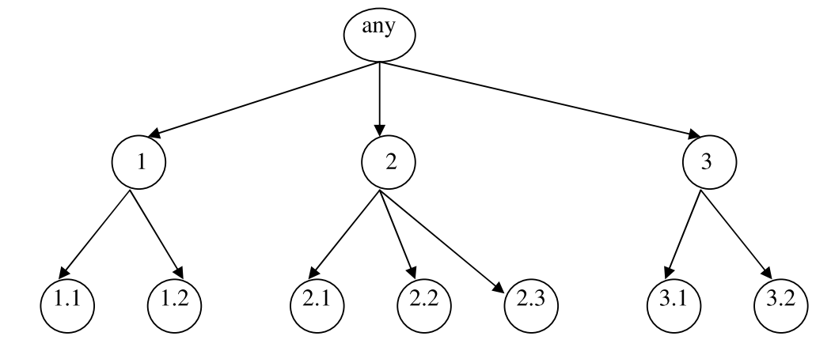
Figure-1 Example of tree structure hierarchy
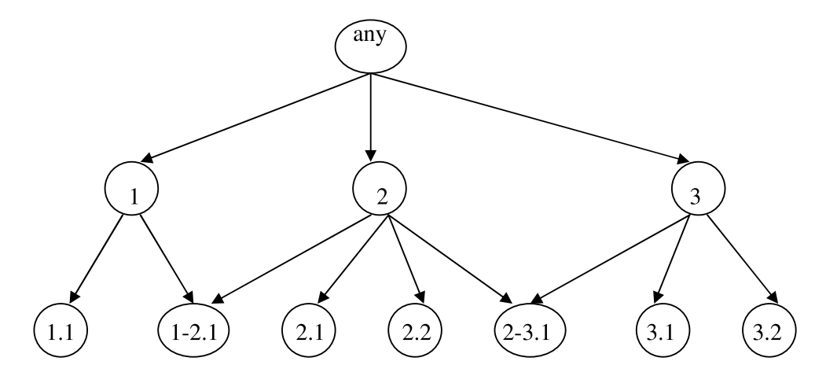
Figure 2 Example of DAG structure hierarchy (Freitas, 2007) of one leaf node has two parents.

The structure needs to be predefined while addressing business problems. Some problems like protein analysis may require specific to DAG-based structure rather than a general tree-based structure because of its genes relations between different groups of classes. But in our problems of high dense text classification general tree-based structure could suites well for the problem statement.

According to (Silla and Freitas, 2011) problem of determining hierarchical classification mainly depends upon three main criteria’s 1) structure of the business problem to evaluate approaches between tree vs DAG this has to be determined closely based on the business problems. For say if we business objective to address tree-based structure one of the optimal solutions could be applying classification to either a top-down approach or bottom-up approach this would narrow down the learning. 2) how much depth involved in classification for saying the tree is the very high depth and more centric on leaf nodes it may be a good idea to apply classification from top-down this will enable the algorithm to optimize because the number of learning required will be reduced. 3) choice of the hierarchical classification algorithm, which could be either one of these approaches top-down/bottom-up or perform flat classification and do some post-processing to enable classification hierarchy.

According to (Cerri et al., 2014; Silva-Palacios et al., 2017) most of the top-down approaches use local information to predict unlabeled data, generally, top-down classification has three variations

2.4.2 Local Classification per Node (LCN)

In this method process is to learn each node separately for binary classification and based on the result going down towards each leaf node. The main objective of this method is to discriminate between siblings. This method conventionally simple method and like any binary classification, however, this approach learns in an iterative amount the classification tree one at a time in each node. the main problem with this approach is if a higher-order class is wrongly classified all the rest of the classes will be automatically under incorrect classification.

2.4.3 Local Classifier per Parent Node (LCPN)

In this approach technique is to learn multi-class classification at each parent node and drive top to bottom based on hierarchy prediction at the parent node. This approach compared to LCN carry most local information at each parent node. of course, this method will also have the same problem of LCN if any of the parent nodes misclassify it resulting in the incorrect classification for the entire flow from down to that level.

2.4.4 Local Classification per Level (LCL)

In this method to learn multi-class classification at each level and based on the results flow towards the end. This approach defiantly the most cost-saving effort in terms of computation and the number of learners required in the classification chain. At the same time if top-level has a wide range of nodes this may be resulting in a burden for LCL to discriminate classes. And another problem with this method it ignores parent-child relation which was instrumental in taking advantage of class hierarchies(Weiss, 2020).

2.4.5 Global classification

It is a method of learning a single classification task to learn across all classes. This approach provides a very thin model compared to any of the local learning methods. Although this method gives a very thin model, local learning approach carries the advantages of learning space information this will make better accuracy of learning compared with global classification.

The approach defined in LCN indicates a significantly costly method comparing with any other classification chain method at the same time LCL indicates even it is a more cost-effective solution in terms of computation it is not taking advantage of the class parent-child relationship.

(Silla and Freitas, 2011) did a comprehensive study of various architectures of hierarchical classification and its general advantages compare with multi-class classifications? In his observations even local classifiers are simple to implement by taking advantage of the existing wide verity of resources of single-label learning some type of local classifiers are suffering from inconsistence and also he states LCL and LCPN quite good for the small number of class labels.

2.4.6 Constructing Hierarchical class

Most of the information that appeared in the real-world will not come with the predefined hierarchical class, for example like document classification, usually document management systems will support to tag various classes without specifying hierarchical classes. Challenge is to learn the technique of how we can learn the structure of hierarchy from flat multi-class labels (Freitas, 2007).

The main idea behind (Wang et al., 2001) is assumed that two classes are similar when classifiers produce similar classification results. And the arriving hierarchy will be based on the incorrect classification. The overall approach is learning the first one vs rest for all the classes in the data set and see which the classes are are giving major errors in the classification. For example, let's assume if the data set has 5 classes (“sports”, “politics”, “education”, “health” and “cricket”) when we construct one vs rest classification for all 5 classifiers and if errors on wrong classifications are high for “sports” and “cricket” it gives evidence to say these classes are related that’s the reason why classification failed to discriminate the differences between “sports” and “cricket”.

(Li et al., 2003) proposed using Linear discriminative projection to identify the class set similarities unlike to the above approach of using classification to determine class set similarities. In this approach first transformed class to the coordinate space and measure class similarities based on the distance between classes in the Euclidean space. The first used the LDA process to identify the number of topics in the text corpus. Then the process is to construct a class topic matrix and measure the Euclidean distance between class to class. Once these measures are available author used Hierarchical Agglomerative Clustering (HAC) algorithm to determine the class relationship. This method seems robust method/computation saving comparing with the classification chain technique to measure class similarities.

In both above experiments, the authors used information related to each class / class-set to determine the relationship between classes and further used similarities scores to construct class labels. (Soni et al., 2017) proposed to use class co-occurrence to measure the similarities and label coherences. In this experiment constructed label tree-based cooccurrence of labels. the idea behind is if some labels appeared frequently together those labels could be similar. One main advantage of this technique will handle classes with very few occurrences, however, the disadvantage of this approach is mainly not considering the class-set information (i.e documents belongs to the class) which could not address appropriate tree hierarchy.

2.5 Neural network implementations

In his comprehensive survey (Minaee et al., 2020) presented several variations of Deep Learning architectures and expressed in opinion Recurrent Neural Network variations (RNN) indicates better performance over plain vanilla feedforward neural networks because RNN will capture the word dependencies between previous and later part of a word in a sentence. He also expressed Long Short-Term Memory variations of RNN often show better performance over vanilla RNN because of LSTM has three important components in the unit, it strongly addresses gradient vanishing problems. (Zhou et al., 2016) in his research author proposed bidirectional RNN. First documents are processed through Glove 3-word embeddings and applied bi-directional LSTM with 5 hidden units. Followed with applying 2d convolution layer, max pool layer, and finally connected to a dense fully connected layer to predict document classification. His experiment proven mixture of bi-directional LSTM-2DCNN layer outperformed all previous benchmark results.

Even though RNN showing extreme performance on the language models they still suffering from computational cost. Especially in bi-directional RNN computation cost is extremely high, hence it became very difficult to train a model with superior generalization. Transformers on the other hand overcame this problem with multiple attention frameworks to compute attention scores for every word in the sequence and apply the influence of word in the sentence. Although attention is used mainly on a sequence to sequence tasks, (Chang et al., 2019) showcased a method to fine-tune transformers for document classification tasks.

2.6 Domain-Specific

(Chen et al., 2017) first processed documents through word2vec to project document into one-dimensional vector space. Further used dimensions extracted through word2vec along with independent word vectors to classify the news item. Used precision @ k to evaluate model performance. It evident that the model learns good precision @k =1 (i.e 0.67) and with an increase of K performance went down drastically for @k=3 (recession 0.38).

Unlike the above experiment of applying classification directly on vector, (Soni et al., 2017) introduced to different post-processing techniques, reranked labels based on probabilistic classification and greedy method applying pairwise probability on the output labels. both these methods show lesser performance over the initial experiment. However, he also tried Steiner Tree Approximation via conditional co-occurrence of labels in the training data to eliminate co-occurrence labels. This method evident in increasing the precision score to 0.69 P@k=1.

(Kowsari et al., 2017) proposed deep learning-based classification chain technique to predict hierarchical classification for document labels. In his approach first level of the neural network will predict the root label and based on the predicted output classification chain will be initiated to predict child labels. this process will continue until it predicts all levels. This method typically followed the pattern of the Local Classifier per Parent Node (LCPN) method, the only variation in his work is to enable classifiers to learn on multiple levels deep networks to improve results. He also experimented with different variations of neural network designs including CNN, DNN, and RNN. Results show that RNN implementations are showing slightly better results over DNN and CNN implementation and it indicates significant improvements over stacked SVM implementation.

(Verma et al., 2020) used a single classifier to predict up to three classes by using a multiple-output neural network. This method could be robust if we have very few predefined levels in the classification hierarchy.

2.7 Summary

In the literature review, we study a comprehensive review of solving multi-label learning type of problem for document classification. Since the topic is widely starched to a different type of technique we first study the general techniques in solving natural next based problems, in this space we reviewed generic practices and involved in the pre-processing of text data and it’s importance’s (lemmatization and tokenization). And then studied techniques for information extraction from text data such as methods of vectorization techniques and LDA. etc. this enables us to review the current advancements in research in processing the text documents for information extraction.

The study also included problem-solving techniques for multi-label learning, to learn existing advancements in the research we first reviewed existing methods in solving multi-class learning (algorithm optimization vs problem transformation techniques) and in the algorithm optimization techniques we reviewed various methods in solving multi-label learning. During this study we understand that classes in multi-class classification generally have some relationship by exploring the options of relation there is an opportunity to increase the learning performance. Further learning the “hierarchical classification” type of method is one of the effective methods for exploring the relationship between classes especially when we have a very wide range of micro granular details.

In this context, we reviewed the problem-solving techniques in hierarchical classification tasks, and subsequently, we also reviewed how to construct class hierarchies from the knowledge of document information. We identified most of the researcher used the classification chain technique to implement hierarchical classification, it is a kind of multiple learnings based on the number of hierarchy levels or several parent nodes. Although in few cases researchers are used a single algorithm to predict all classes in single learning, it comes with the shortfall of the number of levels in hierarchies and expected semantic hierarchical structure (i.e all the leaf nodes in the structure expected to be in the same order in the tree). This evidencing that the classification chain is one of the most common techniques used by the research community in addressing class hierarchies.

The study also considered approaches involved specific to the multi-class classification techniques in the document classification. It is identified that some researchers used post-processing on the predicted value to fine-tuning or eliminating coherence labels which enable to increase the accuracy of predictions. Finally reviewed various deep learning methods and their advantages and limitation in document classifications.

CHAPTER 3: METHODOLOGY

3.1 Introduction

The study is too focused on improving state-or-art accuracy on the multi-class classification problem for large scale news corpus. the study would like to employe current advancements in the language processing & information retrieval tasks and apply to the real-world multi-class classification dataset to improve the accuracy scores in model predictions. If we look into the objective of the research, it can further be subdivided into three main broad sets of activities, this breakdown will help in organizing different stages of milestones in achieving the overall goal.
- Information retrieval (IR) phase :
Information retrieval is one of the challenging steps in text documents. Usually, text documents contain very rich information comparing with the numerical dataset. However, for classification tasks, we may not require all types of information, for example, sentence formate or grammatical information may not be essential for document classification. The essential information such as context or document metadata or topic of documents is important. This study will propose appropriate techniques for extracting necessary information for the document classification task.

- Lable arrangement for Multi-Class classification Phase:
Study to propose an appropriate method for organizing classification labels specific to the news category. Although each label represents specific information about the documents (Silva-Palacios et al., 2017) specified that there will be natural relationships between class labels. if we understand these relations learning, potentially it could help in improving the prediction accuracies.

- Implementing classification algorithm for Multi-class classification Phase:

In this phase, the study will focus on choosing different appropriate techniques in solving multi-class classification. In principle difference between different classification-chain or multi-output neural networks.

The following process document explains the overall process of research and various stages.
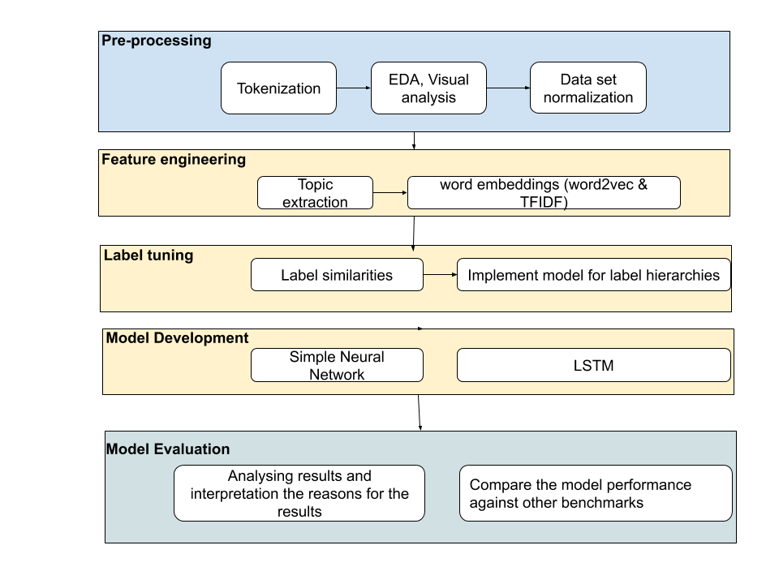
Figure 3 Problem solving process followed during research

3.1 Dataset description

The Data set is publicly available (Yahoo Labs Webscope, 2020), received approval to utilize for academic purposes. However, data is under the yahoo data sharing agreement. As per the agreement, data should not be shared, nor use for commercial purposes, and should not be used to correlate with any other data sources.

This data set is a prime collection of 48,968 news articles. And every news article is been tagged to represent document context. There is a total of 441 fine graded distinct tags in the data set and all these tags are manually tagged by the yahoo newsroom editors. If the article is representative of two or more contexts, the editor chooses all variations of document context and tagged with multiple labels. But labels are organized in a way based on the importance of the context. According to the description provided by the Yahoo, highest relevant tag will precede first and followed with the less relevant information.

Table 1: Description of the database structure
` | Metric
Number of News articles | 48,968
Number of class labels | 441
Average articles word count across a corpus | 573
Median article word count | 468
Number of news articles after removing abnormal documents in sizes  (extremely small and big) | 47,741

3.1.1 Document Analysis ({X}-Labels):

Each document contains an average of 573 words with a median of 468. Corpus indicates some abnormal documents such as a small document being the length as 3 words, larger document with 41512 words. However, we have noticed there are only 2% of samples are having less than 61 words and another 2% of samples are having over 1992 words. There are two issues with these extreme cases, 1) if the document is very small it is very unlikely to extract information related to document context from such documents. 2) if in case documents are very big which makes difficulty for applying machine learning techniques especially nontime variant algorithms. Because except RNN type recurring networks remaining all machine learning and deep learning algorithms expect the same number of parameters as an input for all samples in the dataset. If we have more words some alternative approaches like feature pooling or dimensionality reduction algorithms specific to the large set of documents. to avoid this approach is to eliminate these extreme samples from learning. The following figures show the number of words distribution in the entire data set prior and after adjusting boundaries for data set selection based on the size of the text.

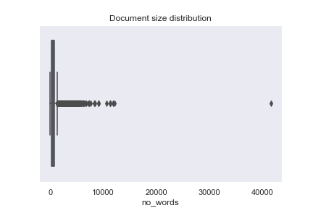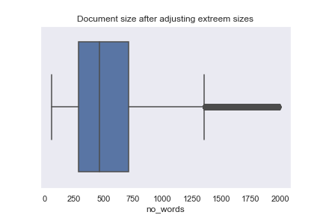
Figure 4: Original Document length distribution
Figure 5 : After elimination of extreme documents

By looking at the above Figure V, indicating that the median of document length is close to the 500 words. And the major end of the boxplot indicates that even after Quartile-3 + 1.5% of interquartile distance we have still few documents that are higher than 1500 words in length. These extreme cases can further be excluded from the study to avoid any imbalance in the dataset.

Table 2 : Number of unique word and its number of times occurred in the data set
 | No of Words
Number of unique words in the corpus | 238,462
Number of unique words after removing stop words | 238,104
Number of unique words after applying stop words and lemmatization | 225,155
Number words occurred at least 5 times | 78368
Number of words occurred at least 10 times | 53679
Number of words occurred at least 500 times | 5500
Number of words occurred at least 1000 times | 3338

Above Table 2 indicates that the number of unique words in the corpus is very big, removing of stopwords will not have a major impact on unique words however for model building stopwords (‘language construction”) parameters will not have any major impact so we will remove to reduce the impact on learning. We also study the possible effect of different forms of a word representation by adjusting to its root form (removing tense from word) even after that number of unique words indicates very big.

It also indicates that even we have 225K unique words a major number of words indicates occurred only one or less than 5 times in the entire corpus a few of such words are (“giblets- means some bird meat”, “Diavolo – some cartoon character”) it make sense these words either very less common therefore when we are working on generic concepts it is a good idea not to consider such words for classifications. On another hand, there are few words “activists” “craft”,” poker” been appeared more than 1000 times in the corpus which make that these are definitely will help in discriminating the document for its classification.

The below picture “Figure 4” indicates that few terms like “New”, “Said”, “Year”, “comment” and “people” indicate a high number of occurrences. This indirectly justifying the context of the corpus. In news reports, it is a very common reporter says some “X said” this information or this comment. etc.


Figure 6: word cloud representation of the text documents shows most freqent words in the corpus

3.1.2 Label analysis ({Y}-Labels):

In the data set, there are 413 distant fine graded tags, each observation in the data set is assigned one to many labels are attached. As per the definition order of labels are represents the importance of the context of documents. on average there are around 2 to 3 labels are attached to each observation, in very few cases some documents have more than 4 labels. figure 3.5 represents the distribution of the number of assignments for each document in the corpus.
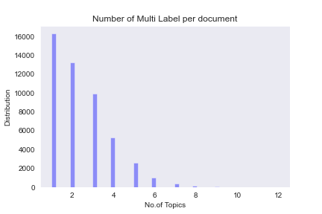
Figure 7: Number of labels distribution
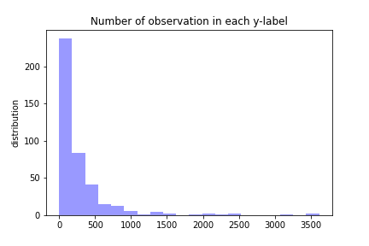
Figure 8: Number observations per label

We also observed that some labels are assigned to a large number of observations and some labels have only a few examples. Figure 8 shows the distribution of labels to example.

Further, we studied, how are these labels have any relationship between them, to understand this aspect we first established a co-occurrence matrix between labels, this process enables us to identify a few set of label coherences below Table 3 will show few co-occurrences.

Table 3: Few examples of common label cooccurrence attached to the same new article.
Label-1 | Label-2 | Cooccurrence
investment | investment-&-company-information | 3081
investment-&-company-information | money | 3017
crime-&-justice | crime-&-punishment | 2010
celebrity | hollywood | 1531
economics | economy-of-the-united-states | 1164
budget,-tax-&-economy | economics | 1160
world_news | disasters-&-accidents | 1158
company-legal-&-law-matters | laws-and-regulations | 681
military-&-defense | u.s.-military | 607
movies | hollywood | 468

The above table shows “investment” & “ investment-&-company-information” both labels are coherence and represent the same meaningful information. At the same time even though “investment-&-company-information” and “money” also popped into the list it should not be considered as coherence because both are representative of different meaningful information. However, these tags have parent or child relationship through visual observation. In the subsequent section, we will review appropriate techniques for addressing both coherence and co-relations between labels, this process will essentially help in improving results.

3.2 Data pre-processing

Text content is a naturally complex job for mathematical models to learn and inference, the following process will simplify this complexity and enable us to implement probabilistic/discriminative models. The idea is to implement a two-step preprocessing method; in the first step, we will apply methods to clean input documents and then eliminate documents that may not add any value for our analysis. In the second step, identify all redundant tags and prepare the data set for the experiment.

During the first step, the following activities will help to perform document cleaning (Jurafsky and Martin, 2019)
- Language Detection: apply standard language detection algorithm and filtered out anything other than English
- Use the process to convert the document into the list of words and remove any auxiliary verbs/language constructive words (aka Stop words) and further proceed for word normalization methods such as Lemmatization & Stemming. This process will help in reducing document size and simplify NLP tasks.
- Normalize the corpus, by removing the documents which are very small or very big (for example in the original data set there are documents with just 3 words, this will not help the learning process)

The above-preprocessing step will give conclusive information on the experimental data set. Further proceed for the second step of pre-processing i.e. on target label’s

In this process, targeted to identify document tags most of the time appeared together by using a co-occurrence matrix on target labels. this process will help in revealing redundant labels example as like #crime-&-justice, #crime-&-punishment. Replace all redundant labels with the same meaning of higher-order tags to reduce current micro fine-grained labels from 413 to 50 tags.

The final process of this step is to divide the observational data set into 70%:30%, randomly selected 70% of documents for developing the model, and 30% of data points for evaluating model performance.

3.3 Elimination of coherence labels.

After completion of the above process, we have fine-tuned the data set contain a list of news articles (aka list of words) with multiple tags for each document. However, labels set are very sparse, to understand coherence and the relationship between labels is essential for reducing dimensions in the class label set. The proposed method is to implement topic to vector, (Angelov, 2020) in the observations set. The beauty of the topic of vector implementation it does;t required to remove stop words or pre-processing the original text document. This algorithm has two internal subsections, in the first section of the method extract the number of topics from the corpus. And in the second section of the algorithm convert these topics into the word vector and then project’s the words into the latent space to represent a numeric vector. Other than stop words this model also has another advantage is it can work on unsupervised methods and fit for different lengths of the document text. It is very common in most of the corpus observations will be different sizes. Usually to deal with these variable sizes of documents either some pooling techniques on word vectors to normalize document vector to maintain the same size.

After extracting the topics in the corpus with the unsupervised methods top2vec and LDA (Pandya et al., 2020), the approach is to measure the class-set similarities through the method’s similar to the (Li et al., 2003). This approach will enable us to construct the similarities, in this first topic identified with the top2vec will be mapped to the classes set provided originally for the sample. This process will provide the class with the topic matrix. After determining the class to the topic matrix, the method is Euclidean distance between classes-sets to understand class similarities. This process will be resulting in class-set to class-set matrix with the wights indicates how much similarities are there in the class. Based on the threshold derived, we can sefly say how many or coherence labels and how many or co-relation labels in the dataset. The process will continue to replace all coherence labels with the higher order observations in the label set to eliminate label coherence. This method ensures that we have cleaned the data set with the observations and classes to start developing a language model for the algorithm to learn.

3.3 Feature extraction.

Feature extraction is the process of recognizing patterns in the text and represent in numerical form so that mathematical models can learn the similarities or vice versa between documents in the corpus. Some of the popular methods are bag-of-words (BoW) & Term frequency-inverse document frequency (TF-IDF) and some pre-trained word2vect kind of methods to preserve the semantic meaning of words (Uysal, 2018; Fu et al., 2019). However, for this process, we are going to use two variations
- TF-IDF is a mathematical model to extracts weighted vectors for each document. it is built on the principles of the term that appeared more frequently in a major number of documents that may not help in discriminating to predict the class label. However, this will approach was designed in such a way that if the particular word has been repeated high-frequency times in one document and comparing with another set of documents then the weight of that word for this extraction will be high. Hence this model has a considerable advantage over the normal BoW model.
- Word2vec (Rong, 2014) preprocessed method, each word on the feature set will be the representation of a vector of numerical values (for saying one word can b in the form of 100 or 300 different vectors in general). These vectors keep the information for assessing semantic and syntactic relationships between two words. If in the cosine similarity between two vectors are very close that represent both words are similar. Word2vec uses n-grams of cooccurrence in a big corpus to calculate these word vectors. The approach is to use pre-trained word2vec dimensions which were trained on a big corpus and see how are the performance in model development. Alternatively, we will train our word2vec to compute less dimensional word embeddings so that computation requirements for developing the model will be minimized.

3.4 Proposed Model:

Proposing to develop two variations in model development. The first one is to develop a feed-forward neural network with fewer word dimensions and then subsequently develop a model for different class sets of dense set & finite set. In such a case we know based on data label set definition we can conclude that target label for higher-order context. It also represents based on probability scores first label tag attached to the document represents the high relevant context in nature. This assumption will simplify document classification tasks and train supervised learning algorithms to predict multi-class label prediction with the simple cross-entropy loss. Once the model is fine-tuned to predict multi-class classification with less loss on cross-entropy. Extract prediction probabilities for each testing document and tag 3 labels based on the classification probability and proceed for the second stage of evaluation to calculate accuracy.

Another strategy is to process LSTM for the high dense document dimensions extracted from doc2vec and treat the problem is as multi-class classification and apply the classification separately for a different set of label sets such as dense label set to finite labels. In the classification chain process, we can implement three separate classifications in one after another to predict a maximum of three tags for the document (Wang et al., 2020).

For the first variation described in paragraph 1 of this section, continue with the experiment of three different network architectures

- In natural language tasks in general words, ambiguity is the biggest problem because in nature some words like ‘bank’ will have completely different meanings based on their preceding words ex: ‘river bank’ vs ‘state bank’ both express completely different contexts. (Minaee et al., 2020). we will use the dense variant of the neural network. The advantages with this, it is simple and training will be very fast with fewer complexities in fine-tuning parameters.

- For the second variation, proposed to use combinations of LSTM network to learn from the input document matrix and passed out through several gradient hidden layers and finally three output layers. To map each output separately to three different ordered labels through postprocessing. In this approach output labels need to be reorganized in from one binary vector to represent the target class to 3 binary vectors. Each vector represents one independent unit of class labels. Some documents may have only one context in such cases we will use dummy class labels for all remaining positions in the target data set. This will easily be defining loss function in the training phase for all three-layered outputs(Zhang and Zhou, 2006), in his research proposed BP-MLL feed-forward neural network with the ranking loss function for gradient updates in backpropagation.

3.5 Model evaluation

In multi-label classification, it is essential to include several different conditions to evaluate model performance based on business objective whereas in binary classification we can straight away go with the accuracy or composite measures like AUC and F1 scores. However, in a multi-label prediction model that generates multiple outputs in this case it is important to understand how to treat scenarios like if the model accurately predicts one label and wrongly classifies two other labels? in such cases penalized entire classification may not relevant. And another scenario that if a high-ranked tag is predicted wrong and all other tags are predicted correctly in that case even the model is tag appropriately high number of classes it does not recognize the important context of the document.

To address this natural problem of multilabel classification we wanted an experiment model with both precision @k, for the different k variants [1,2,3]. This will ensure that predicted class is at least part of the higher-order label(Chen et al., 2017).

3.6. Expected Outcomes

Above framework undoubtedly explained various popular methods in addressing the multi-label classification problem, after completion of this stated process we should be able to answer the following questions

- Combinations of various document embedding techniques and network architectures.
- The finest approaches for solving multi-class label prediction modeling. The primary difference between Multi-output vs single output label prediction.

(Poria et al., 2020) showcased several benchmarking data set and improvement of accuracy over the time with the advancement of deep learning research and especially implementations of different versions of transformers.
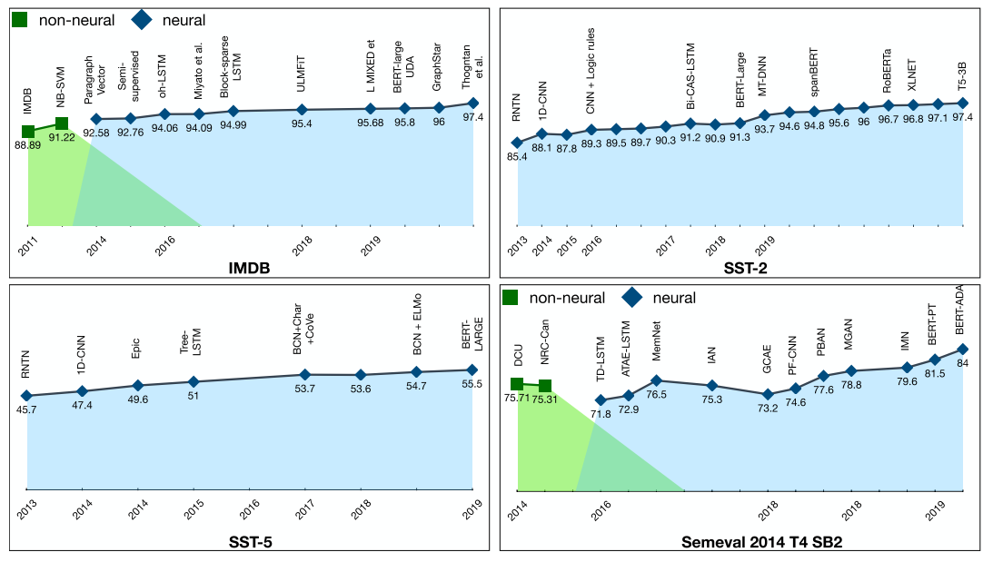
Figure 9: Benchmarking dataset accuracy over time

Previous researchers (Soni et al., 2017) presented precession scores for k top documents (k=1,2,3) at the range of 62% and 68%. We believe by adapting to the new advancements model performance can potentially excel to 70% of precision.

3.7 Summary

The study mainly focusing to cover two fundamental objectives. The first main objective is to study methodologies used for identifying class set relationships and using this relationship to construct the hierarchical structure to identify sub-classes and parent classes.

The second objective focuses on, how to solve the multi-class classification problem specific to the news domain and higher-class coherence. This stage mainly focusses on taking advantage of information gained through the first stage to fine-tune algorithms and methods to get higher accuracy over previous research on the news domain.
In both stages feature learning is one of the critical aspects of the problem area, especially the problem area is related to English new articles collected from various blogs, the domain of classification is very wide. This study strongly depends upon the several supervisor methods like topic models, LDA to extract necessary features relevant to each different tasks.

This study will review a few comparative experiments listed on TABLE IV, suggest the best method for multi-class classification tasks in the news domain.

Table 4: Number of experiments going to be conducted with this research
Experiment | Description
1 | Top2vec – Hierarchical classification -TFIDF – Dense layer Multi-output Neural Network  Extract necessary topics and using this construct class hierarchy in stage -1 of implementation. Then perform TFIDF feature extraction on text document and model multi-label output.
2 | Top2Vec - Hierarchical classification – word2vec –LSTM  Extract topics and construct class hierarchy in stage -1 of implementation. Then perform word2vector embedding and then predict the results through LSTM and dense layer.

CHAPTER 4: ANALYSIS & IMPLEMENTATION

4.1 Introduction

This section will describe the detailed steps performed during the project implementation, it majorly explains the data preparation for model development including feature engineering, and implementation of label coherence / hierarchical structure to enable improving model performance. This section also covers the decisions taken for treating biased/data that was not helping in model development (the process of data cleaning).

The section also, explains the implementation of feature extraction & engineering and methods how we overcame the challenges that arrived during the process. Followed by the explanations of detailed deep learning architecture (DNN & LSTM) and choice of hyperparameters to get better results. And choices of metrics used for evaluating & comparing the results between the models to conclude the performance of hyperparameters.

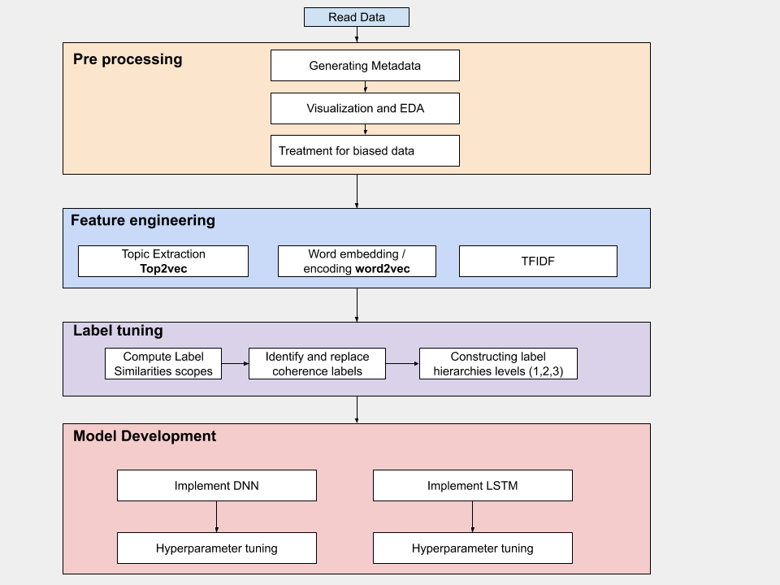
Figure 10: High-level implementation process

4.2 Pre-processing

The data set is provided in the form of a flat-file with the predefined structure, first row represents the unique article ID and is followed by the news tags(labels), in the subsequent line body of the complete article. All the observations are stacked one after one in the same manner. In the first part of the work, recursively read all observations and during this process computed additional basic metadata that helped in performing the basic analysis on the data set, such as the length of an article in a number of words and number of labels assigned to each observation.

During the exploratory analysis of the data set (3.1 Dataset description), we fundamentally noticed there are three fundamental issues on the dataset.

- The number of words in the observations for centra in observations very skewed, i.e some documents are very big and some documents are very small. Even we know that small documents will not help in understanding type or document at the training stage. However, before coming to the judgment, concluded that to run the document cleaning process so that this can enable to assist the number of words required to qualify considering observation into the experimentations.
- The number of observations available for certain y-labels is very low, we know that complex models need a minimum of hundreds of samples to infer patterns.
- By observing a few samples, we noticed that certain labels seem to have high similarity in the context.

From these basic insights on the data analysis, directly stepped into the following activities to prepare the data for model development.

4.2.1 Tokenization and Lexical treatment

After went through some observations, noticed in some cases some of the words are represented in the document in a short form, for example, “can’t”, “I’m”, “u s” or in some documents, some words are clubbed in a single word example, “lifefashion”, “beautyhealthy”. In any NLP activities especially like document classification tasks, usually, the grammatical nature of sentence will not make any value, hence most of the classification tasks we generally exclude the language constrains words like “the”, “is” .. etc. and then start working on the words that mean to conclude the document context. But if we follow that process without treating these common short form words it may lead to loss of potential information for classifying the document. Hence as part of the first step, we proceed to treat this kind of words observed during the document verification.

We used, (Grant Jenks, 2020) open python-based library to understand correct full from the incorrectly grouped word. (example, in some observations “homeusabusiness” {home, use, business} Table 5 will explain some of the similar examples) words were mixed up in the data set and used as one word. Treating this kind of words are important to make a machine / mathematical model to understand. However initially we tried to analyze word segmentation for all the words in the corpus, but this process is taking a lot of computation process, to minimize the computation, we first identified words that longer in the original corpus over 10 letters and run through the word segmentation to understand individual part of words and then replaced the original word with the combination of words identified by the word segmentation. In this process total, we corrected 58,284 words in the corpus.

Table 5: Word cleaned through word segmentation
WORD | Corrected Word(word segmentation)
homeusabusiness | home USA business
writertime | writer time
researchandmarkets | research and markets
prevnextlast | prev next last
firsthighest | first highest
firstoldest | first oldest
usnewswire | us newswire
reportlinker | report linker
educationyahoo | education yahoo
claireglamourcosmopolitanstyle | claire glamour cosmopolitan style
housekeepingdouble | housekeeping double
wellepicuriousgood | well epicurious good
cominstylereal | comin style real
magazineeating | magazine eating
magazinelucky | magazine lucky
fundanalyst | fund analyst

Following this process, we created tokenization for all the words excluding the stopwords (like the word used for language construction the, is, are,.. etc) and then applied PorterStemmer to adjust the words to their root form. This process minimizes the unique word count from 238k to 117k (that means it reduced almost 50% of vocabulary from the original corpus).

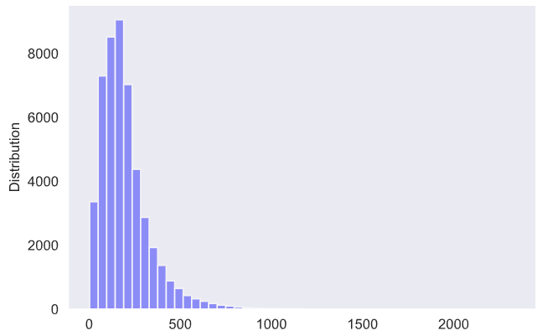
Figure 11: Number of words distribution after applying word treatment

4.2.2 Treatment for extreme documents

During the initial exploratory analysis, one of the major factors identified is that some documents are extremely very big and at the same time some documents are extremely small for a mathematical model to compute and learn, Figure 12 illustrate documents by length, we can see that from box plot anything beyond 500 words seems very big. Further to analyze specific we analyze the distribution of documents understand that there are around 5% of observations have lesser than 44 words and 2% of observations there are above 595 words.
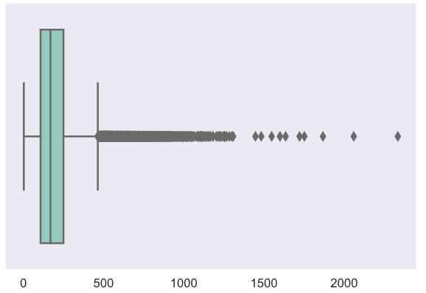
Figure 12: Documents by Length
These extreme documents make out of 3,536 number of documents even we exclude these observations still we ae having 45,432 observations for experimentation.

4.2.3 Label analysis

Referring to section (3.1.2 Label analysis ({Y}-Labels)) noticed that there are 413 labels while verifying the visuals Figure 8, we noticed that some labels are having an extremely high number of observations and some labels don’t have many observations, Table 6 describe the high-level summary of available observations for each label.

Table 6: Number of Observations for label
 | Number of Observations
Labels with lesser than 10 observations | 35
Labels with lesser than 25 observations | 75
Labels with lesser than 50 observations | 105
Labels with lesser than 100 observations | 167
Labels with lesser than 200 observations | 261
Labels with lesser than 500 observations | 326
Labels with lesser than 800 observations | 388
Labels with lesser than 1000 observations | 397

From the analysis Figure 7, we noticed that on average each document was tagged at least by 1.5 labels and some news articles are attached to the 6+ labels. Our verification represent labels that have lesser than 100 observations could be most of the granular details of details, but either to establish this granularity or relationship with another higher-order context we need more observations to conclude. Hence it concluded that progress with the removing labels with lesser than 100 observations per label.

However, this resulting that some of the news articles don’t have any label to understand the context of the news article. Those are 1,542 observations which make the final data set contained 43,890 observations.

4.2.4 Splitting data to train and test

Model evaluation is a very important criterion for arriving at the judgment on the model performance. especially in the modern era of deep neural networks and increasing depth or neurons in the computation process, it is very easy to fit the model for any desired results. Hence it is important to evaluate model performance on unseen data to conclude the judgments on model results.

Randomly split the cleaned observations of 43890 at the ratio of 70% for training and 30% preserved for testing purpose. The approach is to use a training data set for feature engineering, feature extraction, and model development. In this entire process of engineering testing set will keep isolated from experimentation and used only to evaluate the final model performance and compare the results showing in training is similar or not. As long as bot results are indicated as similar on the train and test data set can enable us to conclude the model performance. if any chance model is not performing well or showing highest success on training and failing in test data set will enable us to focus on the scenarios of overfitting and underfitting in order us to tune necessary hyper parameres.

4.3 Feature Engineering

Feature extraction from the test documents is one of the major complex tasks in NLP activities because some proven methods like word2vec could lead to higher dimensions, this will can result in a higher number of parameters to be learned by the model. The objective of this step is to collect the minimum number of words for encoding and minimum dimensions of vector to interpret the similarities between words.

Figure 13: Number of Occurrences of words in Training Data set
The above Figure 13, clearly visible that there are in some words repeated only lesser than 10 times in the entire corpus, these type of words definitely will not add any values to the machine learning application to learn

- TF-IDF
The training data set contain the total number of 117,145 unique words in the X part of news articles. However, after excluding words that occurred lesser than 10 occurrences target became only 27k words. Processed TF-IDF to extract the feature extraction from the X part of the dataset with the following hyperparameters.

Table 7: Hyperparameters for TFIDF
Hyperparameter | Value | Description
analyzer | Word | n-grams are constructed for each word in the token set for training observations
stop_words | English | Removed if any stopwords in the list
min_df | 10 | All vocabulary was ignored for the words that occurred lesser than 10 words.
max_df | 1% | No upper bound for vocabulary
max_features | None | Consider building all qualified vocabulary

- Two variants of word2vec feature extraction are implemented, (1) used pretrained google word vector having 3 billion words with 300 dimensions. (2) fine-tuned word2vec exclusively on the training dataset for the words that occurred at least 10 times in the corpus. however, during early model building, we noticed that the utilization of the pretrained model could be leading to a higher emdebing matrix for example let us say we considered 27k of unique words and a minimum of 250 words per document it is resulting in 27k x 250 x 300. This will need higher computation power and expensive hardware resources for the model to learn. To avoid this we have trained word2vec on the training dataset with the following hyperparameters.

Trail | Hyperparameter | Value | Description
Word_Vec-1 | Pretrained vector | GoogleNews-vectors-negative300 | Attempted using pre-trained word2vec however because of extensive dimensionality, discarded this approach.
Word_Vec-2 | min_count | 20 | Ignores the words that occurred lesser than 20 times.
 | window | 10 | The maximum distance between the current and predicted word. Especially it is news corpus to conclude the relationship we need a larger window size that covering at least one sentence.
 | size | 70 | Size of word embedding.
 | sample | 6e-5 | The threshold for the downsampling on high-frequency words. Because some of the words like “said”, “year” are repeated several times in the dataset.
 | alpha | 0.03 | The initial learning rate.
 | min_alpha | 0.0007 | Learning rate that linearly drops over the number of epochs.
 | epochs | 30 | The number of iterations runs through the corpus.

- Executed top2vec on the training corpus to extract the number of distinct topics in the training dataset. It identified a total of 372 topics from the training dataset, and for each topic what are the high relevant keywords in that topic for us to conclude the quality of topics. The following table describes some of the topic groups extracted by the top2vec. Top2vec doest required cleaned data, it internally processes normalization of words and vectorization hence we processed the original uncleaned body of text as input to top2vec.

Table 8: Topi samples extracted from top2vec
Topic | Top 10 for each topic [Word (word score)]
2 | 'song(0.82), album(0.8), songs(0.79), albums(0.77), band(0.71), songwriter(0.7), singer(0.66), guitarist(0.65), billboard(0.64), drummer(0.63)
0 | prosecutors(0.66), felony(0.64), misdemeanor(0.62), pleaded(0.62), burglary(0.61), sentencing(0.61), aggravated(0.61), charged(0.6), victim(0.6), prosecutor(0.58)
5 | democrats(0.8), republicans(0.79), bipartisan(0.77), congressional(0.75), senate(0.74), overhaul(0.72), legislation(0.72), steny(0.71), congress(0.71), pelosi(0.71)
100 | pastors(0.77), pastor(0.77), church(0.76), churches(0.75), christ(0.73), congregation(0.69), god(0.68), bible(0.67), baptist(0.64), gospel(0.64)
20 | qaeda(0.8), militants(0.78), terrorist(0.74), militant(0.72), attacks(0.71), islamist(0.71), pakistani(0.69), terrorists(0.69), qaida(0.69), al(0.67)

Item (2) in Table 8, clearly given evidence of segmenting the articles that are associated with the songs/movies in the context. And item(0) is indicated for legal/justice proceedings, item(5) indicates political kind of topics, item(100) seems indicates related to religious matters, and item(20) seems to indicate terrorist activities.

Table 9: Hyperparameters for top2vec
Hyperparameter | Value | Description
min_count | 50 | Ignore all the words that have a frequency lesser than 50
embedding_model | Word2vec | Model internally train word2vec from scratch
speed | Learn | This option will enable to learn good quality of words with fewer computation requirements.

4.4 Label tuning

During the initial process, we eliminated 167 labels that have has very little frequency in the data set, resulting in that we have currently had 246 distinct labels to work on the classification task. however, during our EDA (3.1.2 Label analysis ({Y}-Labels)), we noticed that there are certain problems in the data set such as some labels are indicated highly coherence with another similar label or it indicates that some labels are explaining the low-level context to the higher-order label. Without treating this could create uncertainty on the model results because ambiguous in label relevance. Following is the low-level process followed to treat,
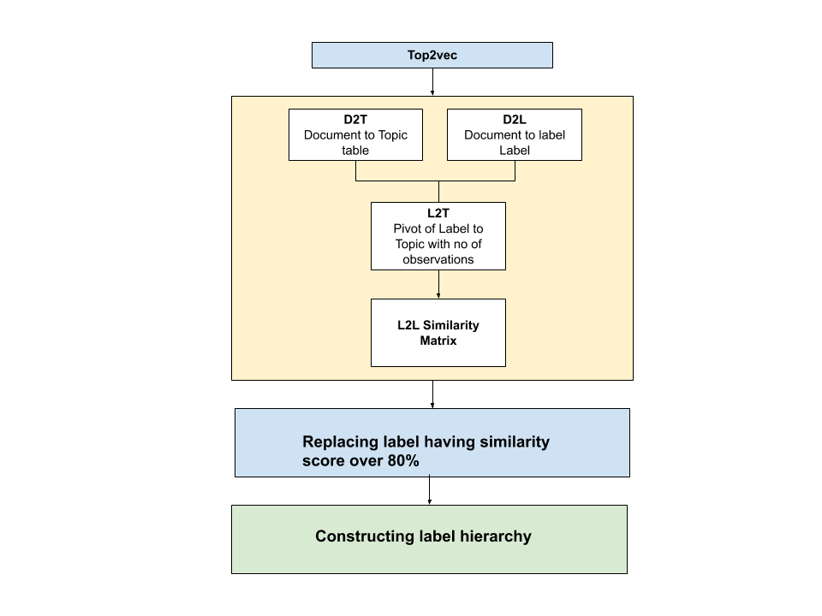
Figure 14: Process of Label treatment

4.4.1 Constructing Document to Topic table

When we run the top2vec, the model identified topics that are specific to the context grouped as one segment, and new articles explaining multiple contexts are grouped into a different topic. This will enable us to extract all documents that belong to a certain topic. From this knowledge, we prepared a document topic table (D2T), that will look like below,

Table 10: Document to the Topic table (D2T)
Document ID | Topic ID
0 | 79
1 | 49
-- | --
-- | --

4.4.2 Document to Label table (D2L)

Referring to the EDA, we understand that each document in the training sent can be attached to 1 or more labels, to make a label to label similarity matrix, we expanded the list of labels organized separate line item for each label. The organization of the document to the label table will look like the below.

Table 11: Document to Label table (D2L)
Document ID | Label
0 | Christianity
0 | Christian
1 | tennis
2 | appliances

4.4.3 Label to Topic relation matrix (L2T)

With the information extracted from D2L & D2T, we constructed L2T matrix for the number of documents that occurred in the segment of each label & topic combination. This will be looks like the below
Table 12: Label to Topic Matrix (L2T)
Topic ID | 0 | 1 | 2 | 3 | -- | -- | 370 | 371
2016_oscars | 0 | 30 | 5 | 0 | -- | -- | 0 | 0
abortion_debate | 5 | 0 | 0 | 0 | -- | -- | 0 | 0
------------- | -- | -- | -- | -- | -- | -- | -- | --
-------------- | -- | -- | -- | -- | -- | -- | -- | --
adoption | 0 | 0 | 20 | 0 | -- | -- | 0 | 0

This table explains, how many observations in the dataset for each combination of the label to a topic. This will enable us to compute the similarities between the labels based on independent topics extracted through to the top2vec without much interpretation considering human labeling.

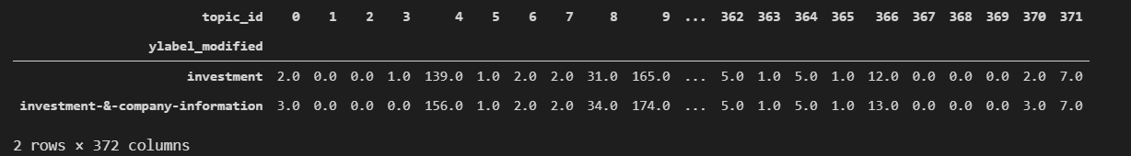
Figure 15 Example of Label to Topic matrix

Figure 15, explains the information collected for two visually related labels “investment” and “investment & company information”. we can notice that for both labels there are a high number of observations grouped under the topics of 4,9.while reviewing these topic how they were grouped topic 4 seeps represtation of corporate relations and company [sedar(0.67), pursuant(0.63), relating(0.59), statements(0.58), applicable(0.58), uncertainties(0.56), exploration(0.56), tax(0.56), hereof(0.56), regulatory(0.55)] and topic 9 seems related to the finance [finance(0.56), liable(0.53), ticker(0.49), boards(0.48), reliance(0.48), quotes(0.47), investing(0.47), headlines(0.47), shall(0.46), actions(0.45)].

4.4.4 Label to Label similarities (L2L)

Even though, L2T gives information on how the labels are related to each other but required to measure the similarity scores at each label to label so that we can understand model coherence or hierarchy between labels.

For each vector or label 2 topics, we measure the cosine similarities between label to label, that transformed table will look like below.

Table 13: Lable to Label (L2L) matrix
 | 2016_oscars | abortion_debate | movies | act-of-terror | -- | -- | -- | adoption
2016_oscars | 1 | 0 | 0.90 | 0 | -- | -- | 0 | 0
abortion_debate | 5 | 1 | 0 | 0 | -- | -- | 0 | 0
------------- | -- | -- | -- | -- | -- | -- | -- | --
-------------- | -- | -- | -- | -- | -- | -- | -- | --
adoption | 0 | 0 | 0 | 0 | -- | -- | 0 | 1

The below figure Figure 16, evident on how the label to label similarities are computed, for example, “space-&-astronomy” & “space-exploration” clearly indicating coherence labels, and at the same time it also evident that topics that were not related. In the above, if the cosine similarity score is near to 1 that can be considered that labels are more close to each other, and as and when the score is near to zero that should be treated that labels are independent of each other.

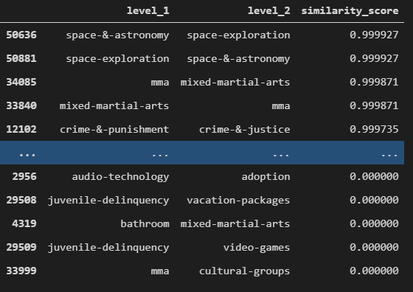
Figure 16: Example of Label 2 Label similarities

4.4.5 Label replacement for recurrent labels

From the above analysis, we concluded that if similarity scores are above 80%, are highly coherent labels, however, this score will only tell us how many similarities between labels, for example, let us say 2016_oscars & Hollywood are indicated 90% similarity, but this scope will not give a judgment to say we need to replace Hollywood with 2016_oscars or 2016_oscars with Hollywood.
To process further, we have taken into consideration of count of observations independently available for each label in the training data set. In the same case for example to say Hollywood was tagged for 1000 observations and 2016_oscars is tagged for only 500 observations, it is an obvious choice to conclude mathematically Hollywood could be the higher-order representation of new context over 20016_oscars. Therefore we have developed the following logic to frame the replacement logic to address coherence recurrent labels.

Var higher_similarties = from L2L where similarity_score >= 0.8

Labels_to_be_replaced = { }

#identify lbels that need to be replaced
For row in higher_similarties:

No_of_obsevations_label1 = count ( from D2L where label == row.level1 )
No_of_obsevations_label2 = count ( from D2L where label == row.level2 )

If No_of_obsevations_label1 > No_of_obsevations_label2:

Labels_to_be_replaced [ level2 ] = Labels_to_be_replaced [ level1 ]
Else:

Labels_to_be_replaced [ level1 ] = Labels_to_be_replaced [ level2 ]
Endif

End for

#execute replacement
For item in Labels_to_be_replaced:

Y_train.replace(item) = Labels_to_be_replaced[item]
Y_test.replace(item) = Labels_to_be_replaced[item]
End for

#replace duplicates if any because example same article was tagged ealiear by movies and oscar, and our process replaced Oscar with movies, we have now attached movies twice
Y_train = set(y_train)
Y_test = set(y_test)

REFERENCES

Based on the above implementation, this process was implemented recurrently until replace all coherence labels based on the similarity score. This will give us advantages over the confusion on which one needs to be replaced first with what label and also if there are three sets of labels having mutual similarity which one needs to be considered as the primary label. For example, the label set like [“movie-reviews”, “2016_oscars”, “movies”] shared higher similarities between all the combinations, however, this iterative process overcame complexities of identifying primary label. It first replaced “movie-reviews” with “2016-Oscars” even we know that movie-reviews are a generic form of context but this during the time on which is data set is collected could be a high time of Oscars awards. Because of this reason, it was initially incorrectly replaced with movie-reviews. However, in the subsequent level, this label was correctly replaced with the more generic representations of “movies”.

Table 14, represent some example of replaced labels and order in which label replacement process was executed. This process replaced 66 labels

Table 14: Example of Labels replaced with high similarity scores
Coherent label | Replaced with
movie-reviews | 2016_oscars
2016_oscars | movies
pregnancy-termination-services | abortion_debate
NFL | American-football
animal-science | living-nature
armed-forces | military-&-defense
auto-insurance | politics
nail-art | beauty
nail-polish | beauty
skin-care | beauty
bedding-&-linens | furniture
security-upgrades-&-downgrades | bonds
budget,-tax-&-economy | economics
celebrity | Hollywood
Christian | Christianity
glbt-issues | civil-rights
marriage | civil-rights
clothes-&-apparel | fashion
painting | collecting
collecting | visual-arts

4.4.6 Construction of Label hierarchy

Now that we are left with the labels that have lesser than 80% similarly, but while when we analyzed the frequency of labels on the training data set, we noticed that some of the labels have very few examples, and some labels still showing a significant amount of similarities. To increase the efficiency of the model we have implemented logic for determining the hierarchical structure of labels with the below process.
# Prepare the similarity scores for the remaining labels in the form of Label1, Label2, similarity score, no.of.obsevations in level 1, number of obsevartions in level 2]

L2L = [Leve1, Leve2, Simiarity_score, No_of_level1_Obsevrations, No_of_leve2_obsevations]

L2l.hirarchy_rank =-1
Rank=0

Count_of_unidentified_ranks = count( where L2l. hirarchy_rank =-1 )
_levels =[root]

While ( Count_of_unidentified_ranks)

If L2L[parent == _levels ]. hirarchy_rank = rank

_levels = identified all higher order levels from L2L

Rank+=1

End while

The above process framed 61 labels at the higher-order level 0 and, subsequently 77 labels framed as level-1 and 21 labels in lave-3 and one label in level-4.
Table 15: Level -0, 61 labels
['investment', 'hollywood', 'crime-&-justice', 'political-parties-&-movements', 'social-&-online-media', 'disasters-&-accidents', 'unrest,-conflicts-&-war', 'travel-and-transportation', 'economics', 'handheld-&-connected-devices', 'business-services-&-activities', 'society-&-culture-organizations', 'music', 'news', 'books-&-publishing', 'teaching-&-learning', 'government-agencies', 'american-football', 'civil-rights', 'travel-organizations', 'public-health', 'lifestyle', 'home-decorating-&-interior-design', 'travel-destinations', 'religion-&-beliefs', 'pharmaceuticals-&-drug-trials', 'sports', 'nature-&-environment', 'employment-&-career', 'personal-budgeting', 'space-exploration', 'medical-specialties-&-services', 'disease-&-medical-conditions', 'colleges', 'soccer', 'immigration-issues', 'parenting', 'political-demonstrations', 'diet-&-weight-loss', 'renewable-energy-&-energy-saving', 'ethnic-group', 'realestate', 'unions', 'beauty', 'wedding', 'golf', 'sex-&-relationships', 'jewelry-&-watches', 'pets', 'performing-arts', 'homelessness-&-housing', 'natural-resources', 'gaming-&-lottery', 'video-technology', 'motor-racing', 'furniture', 'recreational-watercraft', 'mixed-martial-arts', 'cricket', 'dental-care', 'boxing']

Table 16: Level -1, 77 labels
['health-care-policy', 'internet-&-networking-technology', 'foreign-policy', 'sectors-&-industries', 'death-&-funeral', 'stock_market', 'laws-and-regulations', 'mergers,-acquisitions-&-takeovers', 'autos', 'cultural-groups', 'video-games', 'natural-phenomena', 'visual-arts', 'travel-accommodations', 'baseball', 'company-earnings', 'state-budget-&-tax', 'technology', 'tax', 'fashion', 'banking-&-budgeting', 'tests-&-procedures', 'contests-&-giveaways', 'family-health', 'biology', 'travel-transportation', 'human-rights', 'politics', 'mental-health', 'recipes', 'unemployment-issues', 'pollution-&-waste', 'mortgage-loans', 'act-of-terror', 'finance', 'conservation-&-recycling', 'addiction', 'public-transportation', 'financial-aid', 'exercise', 'climate_change', 'organized-crime', 'central-banks', 'ice-hockey', 'tennis', 'lawn-&-garden', 'family-&-relationships', 'bathroom', 'racism', 'poverty-&-welfare', 'appliances', 'skiing', 'dating', 'lobbying', 'holidays-&-celebrations', 'hiv-&-aids', 'movie-reviews', 'lighting-&-accessories', 'education-supplies', 'water-resources', 'labor-issues', 'alternative-medicine', 'food-safety', 'musical-instruments', 'dining-&-nightlife', 'agriculture', 'cameras-&-photography', 'adoption', 'divorce', 'audio-technology', 'horse-racing', 'cartoons-&-comics', 'bedding-&-linens', 'rugby', 'toys', 'workplace-health-&-ergonomics', 'domestic-violence']

Table 17 Level -2 22 labels
['financial-technical-analysis', 'cultural-festivals,-concerts-&-shows', 'insurance', 'living-nature', 'physical-disabilities', 'islam', 'financial-fraud-prevention', 'bonds', 'senior-health', 'robot', 'retirement', 'nuclear-policy', 'politics-&-government-events', 'heart-&-vascular-disorders', 'society-&-culture', 'home-safety-&-security', 'debt-management', 'arts-&-crafts', 'etfs', 'abortion_debate', 'eye-care']

Therefore this process minimizes the labels of size from 160 at the same level to the higher-order labels of 61 granular details at the level=0, and the rest of 99 labels are organized down in the hierarchy. This will enable us to model the classification task for 61 labels with most of the higher-order granularity to represent the news articles.

Table 18: Example label hierarchies
Example | Hierarchy (from bottom to top)
1 | nuclear-policy -> foreign-policy -> unrest,-conflicts-&-war -> root
2 | Bonds -> stock_market -> investment -> root
3 | Toys -> parenting -> root
4 | financial-fraud-prevention -> internet-&-networking-technology -> business-services-&-activities -> root
5 | Racism -> ethnic-group -> root
6 | unemployment-issues -> economics ->root
7 | organized-crime-> -> crime-&-justice -> root
8 | Addiction -> crime-&-justice -> root
Table-18, describe the relationships build by the algorithms to minimize the label dimensionalities, it evidence that 99% of times correctly categorized the hierarchies but in some cases it indicating some level in hierarchies were not be correctly identified but it is completely based on the observations arranged for conducting experimentation. For example in item-1 of Table-18, foreign-policy is populated under the tag of “unrest,-conflicts-&-war” this hierarchy may not be correct in general senses. In general speaking unrest or dealing with conflicts should be under the higher-order label of foreign policy.

In another example, both addictions and organized crime populated under the higher-order label of crime-&-justice, however, when the model is concentrated only on higher-order label classification addiction kind of high sensitivity information could be missed out in the classification.

Based on these hierarchical structures, we created three additional y-labels sets in both training and testing data set to represent one filed to represent only level-1 of hierarchical structures and field level-2 to represent labels presented on 1,2 levels of hierarchies, and so on. During the process of creating target labels for level-1, we also consider if any other level is present that has been replaced with the identified level-1 label. For example in the data set certain observations were initially tagged with [“organized-crime”, “Addiction”, “unemployment-issues”] we constructed target label for level-1 is [“crime-&-justice”, “economics”]. In this case, both crime and addiction were replaced with crime-justice, and unemployment was replaced with economics.

Similarly, we constructed there additional fields, one to represent level-1 labels of observations, level-[1,2] set of observations, and level-[1,2,3] set of labels in both training and test data set for proceeding model development.

4.5 Model Development

Now that we have both x part features are available and Y-part of labels are available we have implemented neural network models to predict the multi-class / multi-label classification in mainly two variants.

4.5.1 Deep Neural network

In this implementation, we developed a simple multi-layer neural network with a feedforward design. This network will take input dimensions extracted from TF-IDF vectorization space and all y labels are in the form of 61 labels to target predicting level-1 of output labels.
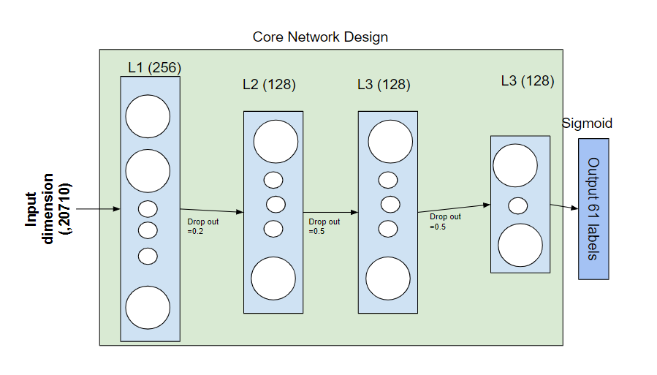Figure 17: Deep neural network low-level architecture

Figure 17, shows mainly there are three blocks,1) input layer, 2) core network layer, and 3) output layer. With the same design of core network design, we trained a total of three different layers to predict level-1 of (61 distinct labels), level-2 (138 labels ), and Level-3 of the set (159 labels).

Layer | Hyperparameter | Value | Description
Input Layer | input_dim | 20710 | TF-IDF extracted features set.
Dense-1 | Units | 256 | Number of neurons
Dropout-1 | Rate | 0.2 | Number of random dropouts from input
Dense-2 | Units | 128 | Number of neurons
 | Activation | Relu | Relu activation function
Dropout-2 | Rate | 0.5 | Number of random dropouts from input
Dense-3 | Units | 128 | Number of neurons
 | Activation | Relu | Relu activation function
Dropout-3 | Rate | 0.5 | Number of random dropouts from input
Dense-4 | Units | 64 | Number of neurons
 | Activation | Relu | Relu activation function
Dense-5 | Units | [64, 138, 159] | Three different outputs with three different models. each model to target the granularity of label predictions from a high level to a low level.
 | Activation | sigmoid | Sigmoid activation for predicting multi-label predictions.
Compile | [Optimizer, loss, metrics] | [“adam”, “poisson”, Precision@k =1) | An executed model with adam optimizer and Poisson loss function for probabilistic positional loss for multi-class classification
Model.fit | Epochs | [20,40,60] | Initially, we executed the model for 20 epochs but after seeing results, increased approaches to get higher accuracy.
Model.fit | Batch_size | [100,500,1000] | Attempted several combinations of batch sizes to increase learning rate however finally satisfied with the batch size of 500.

4.5.2 LSTM recurrent neural network

In the second major variant of implementation, input documents are organized with the word index created of features extracted through fine-trained word2vec. And created an embedded layer in a neural network to fine-tuning embedding and hidden unit parameters.

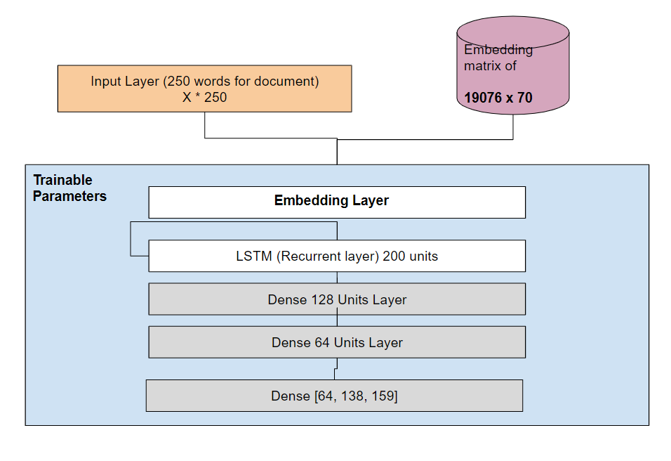
Figure 18: LSTM neural network low-level architecture
The architecture of Figure-18 was trained in three variants, each to address the distent level of details in predicting Level-1, Level-2, and Level-3 of class labels. For input to take flow into the network, we developed a transformation function to transform words within each news article to transferred to the index of which it is available in word2vec. If an index is not available we have replaced that word index with zero. This process is the same for all three different training output parameters.

Layer | Hyperparameter | Value | Description
Input Layer | input_dim | 19,076 | The number of distinct word words was processed through word2vec.
Embedding | Input_length | [250,300,350] | Considered different variations, however, it was concluded that with the minimum of 250 words results are very close to an even higher number of words.
Embedding | output_dim | 19076, 70 | Word2vec trained index size
Embedding | weights | List of 1076,70 | Word2vec matrix
Embedding | trainable | True | This parameter will enable to refine the vectors identified by word2vec to fine-tune weights
LSTM | Units | 200 | Number of LSTM units
 | Dropout | 0.2 | Dropout from input
 | recurrent_dropout | 0.2 | Dropout in the recurrent unit
Dropout-1 | Rate | 0.2 | Ignoreing 0.2 of inputs.
Dense – 1 | Units | 128 | Number of neurons
 | Activation | Relu | Activation function
Dense-2 | Units | 64 | Number of neurons
 | Activation | Relu | Activation function
Dense-3 output | Units | [61,138,159] | Each variant of training is targeted different level of output labels.
Compile | [Optimizer, loss, metrics] | [“adam”, “poisson”, Precision@k =1) | An executed model with adam optimizer and Poisson loss function for probabilistic positional loss for multi-class classification
Model.fit | Epochs | [20,40,60] | Initially, we executed the model for 20 epochs but after seeing results, increased approaches to get higher accuracy.
Model.fit | Batch_size | [100,500,1000] | Attempted several combinations of batch sizes to increase learning rate however finally satisfied with the batch size of 1000.

4.6. Tools

Following section list out all the required resources for implementing above stated methodology.

4.6.1 Hardware requirements

In this study, the experiment conducted in both personal PC and some of part of experiments was conducted in google colab.

- Intel Core i7 2.6GHz and 2.59GHz 6 core process
- 24 GB Ram
- Windows 10
- NVIDIA GeForce 1660 Ti 6GB dedicated RAM
- Googlle colab for running LSTM based model.

4.6.2 Software Requirements

- The experiment will be used PYTHON 3.6

- For Text pre-processing will be used Word2Vec pretrained Google news 300-dimension vector for each word.

- Python Sk-learn package for TF-IDF

- Top2vec for extracting topics from new articles

- Word segmentation library from pip for correcting some of the words.

- Keras , TensorFlow for DNN and LSTM implementation

- Seaborn, matplotlib for visuall analsys

- Numpy, pandas, sklearn for data management

4.6. Summary

The study started with analyzing the data set and come to conclusions of what are the gaps in the data. During this exploratory analysis, we fundamentally identified two major concerns 1) unbalanced news articles 2) highly redundant labels in the data set. Initially, we focused on the basic NLP processing technique to clean the text data for model readiness, with the help of basic visualizations, high occurrences, and word segmentation kind of tools. Subsequently, we stepped into analyzing the labels in the dataset. With the use of top2vec (topic vector), we could able to identify the different topics that exist in the data set. With the help of topics and labels, we prepared algorithms for computing label similarities. Based on the similarities we concluded labels that are appeared to be completely redundant and labels that have some hierarchical structure within the labels. After processing these knowledge maps, we reorganized labels for implementing model readiness.

During this process, we minimized initial labels 413 labels into the 3 groups of [61, 138, 159] labels set in the order of the first set of labels represent some higher-order context and second set of labels representing intermediatory level granularity and 3rd one is a very deep level of granularity.

We also model the data transformation for the cleaned word documents into the two vectorization techniques [TF-IDF, word2vec] for model development. Following this process, we created two neural network models [DNN, LSTM] based neural network and during the training phase, did some fine-tuning to the basic parameters such as a number of layers, units, cost functions, optimizers, and parameters like epochs, batch sizes to get the optimal results from the two models.

CHAPTER 5: RESULTS AND DISCUSSIONS

5.1. Introduction

This section will discuss the implementation results especially comparing with the model outcome and compression between DNN implementation vs LSTM versions. We will also discuss the assumptions taken during the implementation and what are the area it could influence model results.

This section also focused on comparing the results with the previous researcher's produced results and how the proposed model is flexible for using the granularity of the label production. Finally, we will review the satisfaction of aims and objectives of the research and the gaps if any.

5.2. Effectiveness of Label hierarchies

Computations of label hierarchies are significantly helped in producing improved results in overall model development. During this stage, we developed similarity scores between labels and applied methods that can determine labels that are redundant and labels that are having hierarchical relation between them. Based on this computation logic we narrowed down the label set to improve the model performance.

Table 19: Results of Label Hierarchies
Remarks | Number of Labels
Total Number of distant labels in the initial database provided by human labeling. | 413
Labels identified has redundant (withy higher similarity score) | 66
The final set of labels framed to give a high level of granular details on the topics (Level-1) | 61
Set of labels having a detailed level of granular details on each topic (Level-1 & Level -2 together) | 138
Set of labels having a more detailed level of granular details on each topic (Level -1, Level -2 and Level-3 together) | 160

Tables (Table 19 & Table 14) will show the examples archived through this process. However, in this method, we have used a similar score to determine the redundant and hierarchical relationship. In this context following are the major assumptions

- The number of observations per each label in the data sets representation to the near reality to the real-world scenarios, yahoo not interfered significantly with the distribution of the number of observations per label on the provided data set. This assumption is the base for creating a parent to child relationship between labels. For example, the label “disease-&-medical-conditions” has around 311 observations on the train data set whereas labels like having the highest similarities with this group containing less number of observations (“HIV-&-aids”: 108, “biology”: 264) both of these labels were considered are under the parent of “disease-&-medical-conditions”. This is mainly based on the number of observations available in the dataset. Naturally speaking results showing making sense to us based on human knowledge but by any chance, if the data set used for the experiment is not representative of the real-world this may lead to inconsistency on creating a parent-child relationship.

- If the similarity score is more than 80% between any label we considered those sets of labels were highely coherence and redundant. Based on this judegement, we replaced 61 labels with the higher-order parent label. However, if we alter this parameter towords 70% or 65% of the labels that going to be computed as redudent could litter high and this will substantially effect reducing the number of labels classified in level-2 and level-3 of hierarchy henceforth it would lead to improving the much higher precision score. In any case, if we alter this parameter towords 85%+ this may resulting in inaccurate prediction for Level-2 and Level-3. Therefore strongly believe that we have used the correct choice of threshold for identifying redundant.

- We used a threshold of 13% similarity as a minimum qualification for considering building hierarchies. This is again a judgemental number with different experiments, if this parameter is increased towards 20%, the number of labels that would be considered in level-1 will get increased, and resulting in that this could lead to the same status quo of higher dimensions and ambiguous interpretation of label sets.

The above explanation, will evident that thresholds considered are realistic for building label coherence and hierarchies.

5.3. Results of DNN model

This model takes TFIDF word embedding for news articles and predicted the classes for level-1, level-2, and level-3. Precision @k is used as evaluation metric for model evaluation for the k=1, ie it evaluates at least 1 label predicted is part of the training label set or not.

Figure 19: Model-1 DNN Level-1 (61 labels) precision @k =1

Figure 20: Model-1 DNN Level-1 (61 Labels) Categorical Accuracy

Figure 19, represents the precession @k=1 for the training set vs test set during the training phase with the epochs. It is indicated that model learning is incremental along with the epochs and it almost reached to the top state at reaching the epochs of 14. Therefore if we concluded that the model is giving results of 0.71 at the precision k=1. While comparing the results with the previous researcher in a similar context classification, the researchers got the best score of 0.6702. Our model results of 5% better than previous benchmark results for predicting all categories.

When precession @k >2, the precession is getting reduced comparing with the k=1, because the scoring mechanism is trying to validate the number of labels present in the target data set is predicted by the model is a percent or not.

5.4. Results of LSTM model

This model takes embedding created through the word2vec at window 10 and flowed through the connected LSTM with dense layer. Model produced the results for precession@1 is around 0.80 for 60th epochs.

Results indicates far better than the previous model of TFIDF-DNN model, however at the same time if model performance considerably comes down when k in [2, 3], this was expected because evaluation happen for existence of higher number of labels over when k=1 (verifying existence of one label).

In the same time, model execution during the training tame takes considerable more time than DNN model, because as part of model training it needs to be trained for 1.5 million parameters including a huge embedding matrix (20k of words * 70-word vectors) size of memory demand for computation is higher than simplest DNN network.

The same model is evaluated against the different values of k@2, K@3, as well as Label, set of Level-1, Level-2, and Level-3.

5.5. Example Results

The following table describes, few examples comparing with the are the labels initially availed in the data set and how our hierarchical, process fine-tune the labels, subsequently what are the results by the DNN & LSTM models.

Table 20: Model-1, example 1 predictions
Actual Keywords | pregnancy
Level-1 Target Label | parenting
Predicted Keyword by (Level-1 label set) | ['parenting', 'disease-&-medical-conditions']
Body of News Article | health tip what are risk factors for preterm labor health day news a typical pregnancy lasts weeks if labor begins before weeks it’s known as preterm labor being born too early can cause a host of complications ranging from slow growth to problems with the eyes ears breathing and nervous system the American college of obstetricians and gynecologists acog says the acog offers this list of common risk factors for preterm labor having had preterm labor in this or a previous pregnancy smoking cigarettes or using cocaine having a multiple pregnancy for example carrying twins or triplets having an abnormality of the cervix or uterus having had an infection during pregnancy bleeding during the second or third trimester being underweight having a mother or grandmother who took a medication called des during pregnancy having had insufficient medical care before and during pregnancy

Table 21: Model-1, Example 2 Prediction
Actual Keywords | ['amazon.com', 'business-services-&-activities', 'internet-&-networking-technology']
Level-1 Target Label | ['business-services-&-activities']
Predicted Keyword by (Level-1 label set) | ['social-&-online-media']
Body of News Article | amazon takes new approach as it seeks to own black friday yet again this year n as amazon com amzn looks to own black friday yet again this year its fulfillment efforts will be key it s the peak  season for the company said morningstar analyst rj hottovy of black friday adding that the bulk of amazon s revenue still comes from its e commerce marketplace even as it branches into otherbusinesses over the past couple years amazon has enjoyed huge success during the black friday season thanks to its competitive prices and fast shipping speeds last year amazon accounted for about of all e commerce spending last year from nov through dec according to slice intelligence which gathers data from millions of shoppers amazon also reported that it added three million new prime members in the one week before christmas alone jeff bezos empire is evolving from an e commerce retailer to a third party marketplace through its fulfillment by amazon fba program and the transformation will be visible during the upcoming season hottovy said adding that operating a marketplace is more profitable amazon has been building out its fulfillment capacities to allow more third party vendors to store and ship goods through amazon in the third quarter for instance the company opened fulfillment facilities to maximize capacity ahead of the holiday season about of units sold on amazon are now coming from third party businesses hottovy noted

Table 22: Model-1 Example 3 Prediction
Actual Keywords | ['business', 'wall_street', 'stocks-&-offerings', 'stock_market']
Level-1 Target Label | investment
Predicted Keyword by (Level-1 label set) | investment
Body of News Article | bar harbor bankshares increases quarterly cash dividendbar harbor maine business wire bar harbor bankshares nyse mkt bhb today announced that its board of directors declared a quarterly cash dividend of cents per share of common stock representing an increase of cents or compared with the prior quarter and an increase of cents or compared with the fourth quarter of the quarterly cash dividend is payable to all shareholders of record as of the close of business november and will be paid on december bar harbor bankshares is the parent company of its wholly owned subsidiary bar harbor bank trust  bar harbor bank trust founded in provides full service community banking with fifteen branch office locations serving downeast midcoast and central maine find us at www bhbt com

Based on the above examples, we can conclude that the model predicted meaningful information for the cases news articles even if the predicted tag not exactly the same. For example in Table 21, the level-1 hierarchy is 'business-services-&-activities' however DNN Model is predicted “social-&-online-media” which looks similar to meaningful information and similar in the context.

5.5. Model Compression

Following table describe the comparisons of results between various models and with the different level of granularity of label classifications.

Table 23: Model Results & Compression
MODEL | Metric | Number of Labels | Test Data set Score
BASE PAPER | Precession @k =1 | All Tags | 0.6702
DNN | Precession @k =1 | 61 (Level-1) | 0.7277
DNN | Precession @k =2 | 61 (Level-1) | 0.4954
DNN | Precession @k =3 | 61 (Level-1) | 0.3712
DNN | Precession @k =1 | 138 (Level 1 + Level 2) | 0.5727
DNN | Precession @k =2 | 138 (Level 1 + Level 2) | 0.4178
DNN | Precession @k =3 | 138 (Level 1 + Level 2) | 0.3278
DNN | Precession @k =1 | 159 (Level 1 + Level 2 + Level 3) | 0.5761
DNN | Precession @k =2 | 159 ((Level 1 + Level 2 + Level 3) | 0.4248
DNN | Precession @k =3 | 159 ((Level 1 + Level 2 + Level 3) | 0.3342
LSTM | Precession @k =1 | 61 (Level-1) | 0.7654
LSTM | Precession @k =2 | 61 (Level-1) | 0.5329
LSTM | Precession @k =3 | 61 (Level-1) | 0.4022
LSTM | Precession @k =1 | 138 (Level 1 + Level 2) | 0.6732
LSTM | Precession @k =2 | 138 (Level 1 + Level 2) | 0.4955
LSTM | Precession @k =3 | 138 (Level 1 + Level 2) | 0.3880
LSTM | Precession @k =1 | 159 (Level 1 + Level 2 + Level 3) | 0.6167
LSTM | Precession @k =2 | 159 ((Level 1 + Level 2 + Level 3) | 0.4519
LSTM | Precession @k =3 | 159 ((Level 1 + Level 2 + Level 3) | 0.3535

Table 23, describes the LSTM with fine-tuned word2vec is giving better results for P@k =1 for finite labels of 61. When the label space is increased performance indicates P@k Score indicates went down, however, when we analyzed predicted labels mentioned in the examples (Table 20, Table 21, Table 22) indicates that the results predicted by the model is much appropriate in the context.

5.6. Answering research questions

- Does there is any technique to reduce the classification classes from a high dense class set?

With this research, we were able to compute the similarity score by using document topic matrix. And based on the level of similarities we computed the label’s coherent and established a method of using combinations of similarity & number of obsevations on the class set to determine the highrarachical structure among the labels. This process significantly reduces the dimentaions of labels from 413 to the finest labels of 61 and dense labels of 158.

- Does there any advantages to creating a machine learning model for dense label set vs finest label set?

We noticed that, when the label set of high, the precesion scores are comprepatively low for the finest set labels. Therefore we can develop a model only to the target level of details (finest or intermediary or detailed set) of labels depends upon the need of business scenario. This will help the model to reduce wrong classifications and improve the performance for multi-class and multi-label classifications.

5.7. Summary

In this section, first, we evaluate the model performance between the different models and different levels of labels (the finest label set to the dense label set). For each model, we also evaluate the precision score at a different set of label sizes (P@1, P@2, P@3). During this process, we noticed that LSTM through word2vec is outperformed DNN as well as doctag2vec models for each sample size of precision

Following this, we also evaluate the model performance against a few random samples to interpret results extracted with these two models comparing with the labels provided originally. We noticed that model predicted labels are either the same set of labels extracted through hierarchical construction. For the cases where metric scoreless, we evaluate few samples and understand that tags created in the model are also similar in the context of the original label even it is not extract.

Further, we reviewed the research questions, how it was addressed by our end to end to implementations.

CHAPTER 6: CONCLUSIONS AND RECOMMENDATIONS

6.1. Introduction

In this section, we will review how the research is addressed the aims and objectives defined in section 1.3, this section will also summarize the difference in results between high dense labels for news categorization, and our contribution in the framing methodology for constructing a hierarchical class structure, and how it enabling creating a different set of label granularity from finest to dense label sets.

This section will also summarize the overall results archived through the finest set of labels and how it performing compare with the earlier researchers' methods of doctag2vec. And finally, what are the areas future researchers can be concentered to minimize the efforts for multiclass news categorization in a meaningful way.

6.2. Discussion and conclusions

Through the detailed literature review mentioned in section 2, we understand the complexities of dense classes in the news categorization. Classes present in the news data set have no underlying differences in the level of information they explaining, for example, class labels like [“economics”, “state-budget-&-tax”, “unemployment-issues”, “central-banks”] are at the same level. Hence if some observations were only tagged with “economics” and some observations were only tagged with “central-banks” even though both labels represent the similar context of news information. This kind of ambiguous labels will create problems for the machine learning model to understand taking essential parameters for classifying. This is one of the reasons why the previous researcher (Chen et al., 2017) shown results of only about 0.6702 for P@k =1. One of the motivations for doing this research is to identify the appropriate technique suitable for reducing the dimensionality of class labels.

To address this fundamental problem, we focused on understanding the similarities between labels using the training samples we first determine the number of unique topics exists in the target data set through the (Angelov, 2020) top2vec. And then establish a document topic matrix and this enables us to relate existing label mapping to the topics identified. With this knowledge, we computed Label to Topic L2T (L2T is nothing product of document to labels(D2L) and document to topics(D2T)). For each label, we again determine the cosine similarities between labels using L2T, this gives us the label 2 label similarities in terms of percentage represent how much is similar. With the basis of L2L, we developed a systematical approach to identify the labels that are coherent and labels that have parent-child relationships, (the above example was redefined as [“state-budget-&-tax”, “unemployment-issues”, “central-banks”] is under the parent of [“economics”]. This approach enables to reduce label set from an initial 413 to the 61 of finest label set which can explain the essential context of a news item in detail. We also determine three variants of label set one explains the high level of context containing only 61 labels and following with the two additional sets of labels [138,158]. Hence this information can be used for developing the machine learning model without much ambiguity for both the finest set and detailed set of labels.

In our attempt of modeling, we could see that the LSTM version of the model (word2vec features) is outperformed both models of doctag2vec and the DNN model. During our assessment, we also reviewed the model evaluation for two variations

- model performance against different p@k in [1, 2, 3], and results for P@k=1 will have the highest precision score and it degrades when the number of samples increases. This was expected because the wrong classification will relatively increases when the expectation of a number label to be present in the predicted data set.
- We also tested the model for a different set of details i.e labels set of [61, 138, 159]. P@k scores are getting degraded along with labels increases, this satisfies our motivations of creating a hierarchical structure on the label and create the finite set of labels predicting news categories.

The LSTM model for a finite set of labels (61 labels) gives the results of P@k=1 is 0.76, which is approximately 13% higher score than the previous researcher's benchmark scores.

6.3. Contribution to the knowledge

Following are our contributions to the problems of dense label involvement in multi-class and multi-label.

- The methodology of computing label 2 label similarity scores based on the efficient utilization of knowledge gain from the inappropriate human label set along with topics identified through an unsupervised model. This approach can be used in any similar situations of high dense labels in text classification tasks, this will enable the researchers in unifying the labels that are appeared to be similar in context.

- The methodology of using label similarity to compute the parent-child relationship between labels. This will enable the researchers to focus on specific business objective suitable for the level in which it satisfies their requirements. For example, let us say the researcher only needs a very high-level classification of certain documents in this case instead of working on an entire set of flat labels, the researcher can use the above-stated concepts to minimize the label set to root labels.

6.4. Future Recommendations

Both the process of computing label similarities, construction of label hierarchies are helped in preparing the finite set of the label containing 61 labels. however in general if we speak most of the news publications keep the content in 6-20 high-level categories based on their focus area Ex: [“politics”, “crim”, “business”, “sports”, “hyperlocal”, “international”, “lifestyle”, “entertainment”, “science/tech”, “Travel”, “Culture”, “weather” and “investing”], under these section detailed informative content, will be categorized. However, in our development, we had 61 labels at level-1, which this still a very high level compared with how news organizations label the news. In our opinion, this could be mainly because of the following reasons

- Inconsistence in human labeling for the experimental data set and insufficient details for constructing level-1 with only limited to 10 to 20 labels. Due to the data-sharing agreement guidelines, we are restricted from not using any other knowledge from publically available datasets for fine-tuning label hierarchies through cross information. However, in the future researcher could extent this through the process on any public ally available data set and relate knowledge gathered from news publication for defining higher-order label ranks. This will enable researchers to establish much deeper labels of labels to experiment with it.

- In our both experimentations of DNN, LSTM we used a single-output multi neural network to determine the level set based on the business demand out of finite labels to dense labels. however, in the future researcher take forward our development of label hierarchies and use classification chain modeling to develop a single model for all different levels at the same time or an iterative approach to satisfy top-down classifications i.e to one level classification at each stage.

REFERENCES

Angelov, D., (2020) Top2Vec: Distributed Representations of Topics. arXiv, [online] 2020. Available at: http://arxiv.org/abs/2008.09470 [Accessed 2 Sep. 2020].
Anon (2020) Metadata. [online] wikipedia. Available at: https://en.wikipedia.org/wiki/Metadata [Accessed 25 Sep. 2020].
Ashihara, K., Kajiwara, T., Arase, Y. and Uchida, S., (2019) Contextualized context2vec. In: Proceedings of the 5th Workshop on Noisy User-generated Text (W-NUT 2019). [online] Association for Computational Linguistics (ACL), pp.397–406. Available at: http://www-bigdata.ist.osaka-u.ac.jp/ [Accessed 2 Sep. 2020].
Bi, W. and Kwok, J.T., (2011) Multi-Label Classification on Tree- and DAG-Structured Hierarchies. In: Proceedings of the 28th International Conference on International Conference on Machine Learning. Omnipress, pp.17–24.
Bird, S., Klein, E. and Loper, E., (2009) Natural Language Processing with Python. [online] oreilly. Available at: https://www.nltk.org/book/ [Accessed 30 Aug. 2020].
Cerri, R., Barros, R.C. and De Carvalho, A.C.P.L.F., (2014) Hierarchical multi-label classification using local neural networks. In: Journal of Computer and System Sciences. Academic Press, pp.39–56.
Chang, W.-C., Yu, H.-F., Zhong, K., Yang, Y. and Dhillon, I., (2019) X-BERT: eXtreme Multi-label Text Classification with using Bidirectional Encoder Representations from Transformers. [online] pp.1–12. Available at: http://arxiv.org/abs/1905.02331.
Chen, S., Soni, A., Pappu, A. and Mehdad, Y., (2017) DocTag2Vec: An Embedding Based Multi-label Learning Approach for Document Tagging. arXiv.
Dai, A.M., Olah, C. and Le, Q. V., (2015) Document Embedding with Paragraph Vectors. arXiv preprint, [online] 1507.07998. Available at: http://arxiv.org/abs/1507.07998 [Accessed 26 Aug. 2020].
Dudhabaware, R.S. and Madankar, M.S., (2015) Review on natural language processing tasks for text documents. In: 2014 IEEE International Conference on Computational Intelligence and Computing Research, IEEE ICCIC 2014. Institute of Electrical and Electronics Engineers Inc., pp.25–32.
Freitas, A.A., (2007) A Tutorial on Hierarchical Classification with Applications in Bioinformatics. Idea Group Pub.
Fu, J., Liang, L., Zheng, J. and Zhou, X., (2019) Text Categorization by Weighted Features. In: Proceedings - 2018 5th International Conference on Information Science and Control Engineering, ICISCE 2018. Institute of Electrical and Electronics Engineers Inc., pp.544–547.
Grant Jenks, (2020) wordsegment. [online] pypi. Available at: https://pypi.org/project/wordsegment/ [Accessed 10 Nov. 2020].
Holmström, J., Jonsson, D., Polbratt, F., Nilsson, O., Lundström, L., Ragnarsson, S., Forsberg, A., Andersson, K. and Carlsson, N., (2019) Do we read what we share? Analyzing the click dynamic of news articles shared on twitter. Proceedings of the 2019 IEEE/ACM International Conference on Advances in Social Networks Analysis and Mining, ASONAM 2019, pp.420–425.
Iyyer, M., Manjunatha, V., Boyd-graber, J. and Daum, H., (2015) Deep Unordered Composition Rivals Syntactic Methods for Text Classification. pp.1681–1691.
Jabeen, H., (2018) Stemming and Lemmatization in Python. [online] datacamp. Available at: https://www.datacamp.com/community/tutorials/stemming-lemmatization-python?utm_source=adwords_ppc&utm_campaignid=1455363063&utm_adgroupid=65083631748&utm_device=c&utm_keyword=&utm_matchtype=b&utm_network=g&utm_adpostion=&utm_creative=332602034364&utm_targ [Accessed 25 Aug. 2020].
Jurafsky, D. and Martin, J.H., (2019) Speech and Language Processing. Third Edit ed. Prentice Hall.
Kowsari, K., Brown, D.E., Heidarysafa, M., Jafari Meimandi, K., Gerber, M.S. and Barnes, L.E., (2017) HDLTex: Hierarchical Deep Learning for Text Classification. Proceedings - 16th IEEE International Conference on Machine Learning and Applications, ICMLA 2017.
Kowsari, K., Meimandi, K.J., Heidarysafa, M., Mendu, S., Barnes, L.E. and Brown, D.E., (2019) Text Classification Algorithms: A Survey. Information (Switzerland), [online] 104. Available at: http://arxiv.org/abs/1904.08067 [Accessed 25 Aug. 2020].
Li, T., Zhu, S. and Ogihara, M., (2003) Topic Hierarchy Generation via Linear Discriminant Projection. In: SIGIR Forum (ACM Special Interest Group on Information Retrieval). [online] New York, New York, USA: Association for Computing Machinery, pp.421–422. Available at: http://portal.acm.org/citation.cfm?doid=860435.860531 [Accessed 16 Aug. 2020].
Liu, S., Tang, R. and Chai, J., (2018) A news automatic tagging method based on statistical language model. Proceedings - 2017 10th International Congress on Image and Signal Processing, BioMedical Engineering and Informatics, CISP-BMEI 2017, 2018-Janua, pp.1–5.
Lourdusamy, R. and Abraham, S., (2018) A Survey on Text Pre-processing Techniques and Tools. International Journal of Computer Sciences and Engineering, 0603, pp.148–157.
Minaee, S., Kalchbrenner, N., Cambria, E., Nikzad, N., Chenaghlu, M. and Gao, J., (2020) Deep Learning Based Text Classification: A Comprehensive Review. [online] Available at: http://arxiv.org/abs/2004.03705 [Accessed 14 Jun. 2020].
Nam, J., Kim, J., Loza Mencía, E., Gurevych, I. and Fürnkranz, J., (2014) Large-scale multi-label text classification - Revisiting neural networks. In: Lecture Notes in Computer Science (including subseries Lecture Notes in Artificial Intelligence and Lecture Notes in Bioinformatics). [online] Springer Verlag, pp.437–452. Available at: https://link.springer.com/chapter/10.1007/978-3-662-44851-9_28 [Accessed 24 Jun. 2020].
Pandya, M.R., Reyes, J. and Vanderheyden, B., (2020) Method for Customizable Automated Tagging: Addressing the Problem of Over-tagging and Under-tagging Text Documents. [online] Available at: http://arxiv.org/abs/2005.00042 [Accessed 14 Jun. 2020].
Poria, S., Hazarika, D., Majumder, N. and Mihalcea, R., (2020) Beneath the Tip of the Iceberg: Current Challenges and New Directions in Sentiment Analysis Research. [online] pp.1–26. Available at: http://arxiv.org/abs/2005.00357.
Prajapati, P., Thakkar, A. and Ganatra, A., (2012) A Survey and Current Research Challenges in Multi-Label Classification Methods. International Journal of Soft Computing and Engineering IJSCE, 21, pp.248–252.
R, P.C. V, Narayana, S.L. and Divakar CH, (2018) PROBABILISTIC TOPIC MODELING AND ITS VARIANTS-A SURVEY. International Journal of Advanced Research in Computer Science, [online] 93. Available at: http://dx.doi.org/10.26483/ijarcs.v9i3.6107 [Accessed 4 Jun. 2020].
Rong, X., (2014) word2vec Parameter Learning Explained. [online] Available at: http://arxiv.org/abs/1411.2738 [Accessed 24 Jun. 2020].
Schapire, R.E. and Singer, Y., (2000) BoosTexter: a boosting-based system for text categorization. Machine Learning, 392, pp.135–168.
Shelke, P.P. and Pardeshi, A.A., (2020) Review on Candidate Feature Extraction and Categorization for Unstructured Text Document. In: Proceedings of the 4th International Conference on Computing Methodologies and Communication, ICCMC 2020. Institute of Electrical and Electronics Engineers Inc., pp.88–92.
Shi, B., Poghosyan, G., Ifrim, G. and Hurley, N., (2018) Hashtagger+: Efficient high-coverage social tagging of streaming news. IEEE Transactions on Knowledge and Data Engineering, 301, pp.43–58.
Silla, C.N. and Freitas, A.A., (2011) A survey of hierarchical classification across different application domains. Data Mining and Knowledge Discovery, .
Silva-Palacios, D., Ferri, C. and Ramírez-Quintana, M.J., (2017) Improving Performance of Multiclass Classification by Inducing Class Hierarchies. In: Procedia Computer Science. Elsevier B.V., pp.1692–1701.
Soleimani, H. and Miller, D.J., (2016) Semi-supervised multi-label topic models for document classification and sentence labeling. International Conference on Information and Knowledge Management, Proceedings, 24-28-Octo, pp.105–114.
Soni, A., Pappu, A., Ni, J.C. and Chevalier, T., (2017) Post-Processing Techniques for Improving Predictions of Multilabel Learning Approaches. [online] Proceedings of the Eighth International Joint Conference on Natural Language Processing (Volume 2: Short Papers). Available at: https://www.aclweb.org/anthology/I17-2011 [Accessed 21 Jun. 2020].
Sorower, M., (2010) A literature survey on algorithms for multi-label learning. Oregon State University, Corvallis, [online] March, pp.1–25. Available at: http://people.oregonstate.edu/~sorowerm/pdf/Qual-Multilabel-Shahed-CompleteVersion.pdf.
Uysal, A.K., (2018) On Two-Stage Feature Selection Methods for Text Classification. IEEE Access, 6, pp.43233–43251.
Verma, M., Kumawat, S., Nakashima, Y. and Raman, S., (2020) Yoga-82: A New Dataset for Fine-grained Classification of Human Poses. [online] Available at: http://arxiv.org/abs/2004.10362 [Accessed 10 May 2020].
Wang, K., Zhou, S. and He, Y., (2001) Hierarchical Classification of Real Life Documents. Society for Industrial & Applied Mathematics (SIAM).
Wang, T., Liu, L., Liu, N., Zhang, H., Zhang, L. and Feng, S., (2020) A multi-label text classification method via dynamic semantic representation model and deep neural network. Applied Intelligence, [online] pp.1–13. Available at: https://link.springer.com/article/10.1007/s10489-020-01680-w [Accessed 24 Jun. 2020].
Weiss, N., (2020) Hierarchical Classification with Local Classifiers: Down the Rabbit Hole. [online] towardsdatascience.com. Available at: https://towardsdatascience.com/hierarchical-classification-with-local-classifiers-down-the-rabbit-hole-21cdf3bd2382 [Accessed 30 Aug. 2020].
Weston, J., (2001) A kernel method for multi-labelled classification. In: A. Elisseeff and J. Weston, eds., Proceedings of the 14th International Conference on Neural Information Processing Systems: Natural and Synthetic. MIT Press, pp.681–687.
Wikipedia, (2020) Online public access catalog. [online] Available at: https://en.wikipedia.org/wiki/Online_public_access_catalog [Accessed 25 Sep. 2020].
Yahoo Labs Webscope, (2020) Webscope | Yahoo Labs. [online] Yahoo Labs Webscope. Available at: https://webscope.sandbox.yahoo.com/catalog.php?datatype=l&did=84 [Accessed 21 Jun. 2020].
Zhang, M.-L. and Zhou, Z.-H., (2006) Multilabel Neural Networks with Applications to Functional Genomics and Text Categorization. IEEE TRANSACTIONS ON KNOWLEDGE AND DATA ENGINEERING, [online] 1810, pp.1338–1351. Available at: https://www.researchgate.net/publication/3297607 [Accessed 25 Jun. 2020].
Zhang, M.L. and Zhou, Z.H., (2007) ML-KNN: A lazy learning approach to multi-label learning. Pattern Recognition, 407, pp.2038–2048.
Zhou, P., Qi, Z., Zheng, S., Xu, J., Bao, H. and Xu, B., (2016) Text Classification Improved by Integrating Bidirectional LSTM with Two-dimensional Max Pooling. COLING 2016 - 26th International Conference on Computational Linguistics, Proceedings of COLING 2016: Technical Papers, [online] pp.3485–3495. Available at: http://arxiv.org/abs/1611.06639 [Accessed 29 Jun. 2020].

APPENDIX A: RESEARCH PLAN
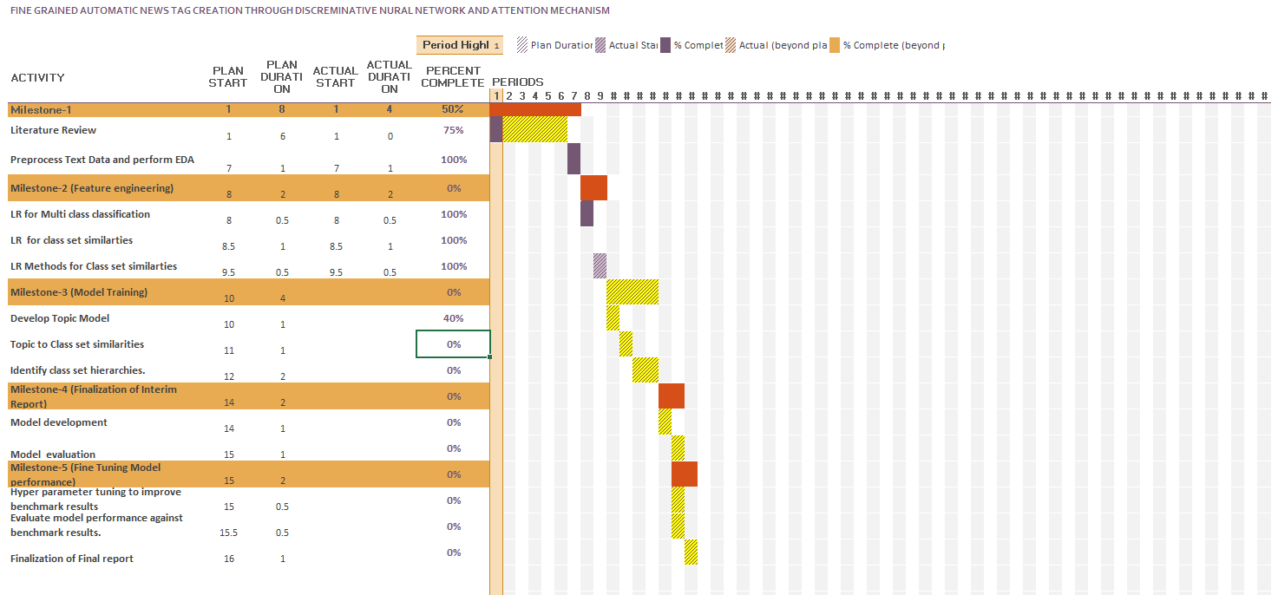

Figure 21: Project Plan

APPENDIX B: RESEARCH PROPOSAL

APPENDIX C: ETHICS FORMS

I am Ranganadh Kodali declared this thesis work is written by myself, wherever few ideas are taken from the previous researchers are credited with the proper citation.

